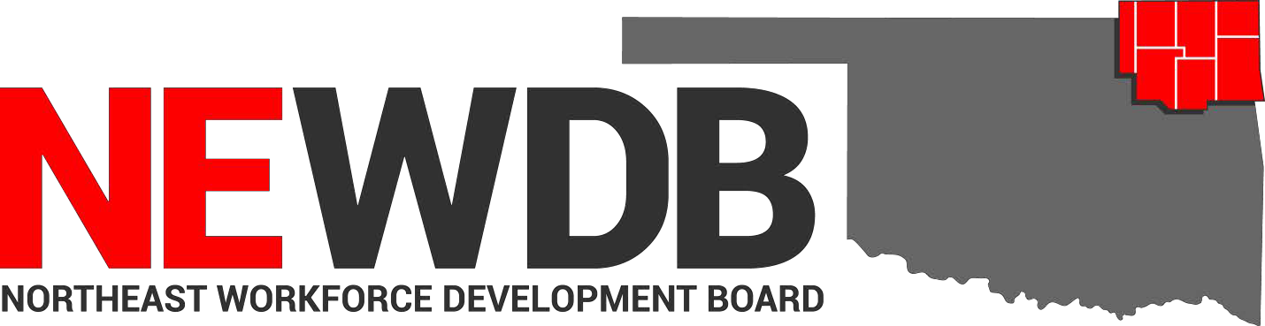

Workforce Innovation and Opportunity Act Approved Training
Programs and Providers

No individual in the United States may, on the basis of race, color, religion, sex, national origin, age, disability, or political affiliation or belief, or, for beneficiaries, applicants, and participants only, on the basis of citizenship or participation in any WIOA Title I-financially assisted program or activity, be excluded from participation in, denied the benefits of, subjected to discrimination under, or denied employment in the administration of or in connection with any WIOA Title I- financially assisted program or activity.

Approved by:

Board Members Present 8.10.2022

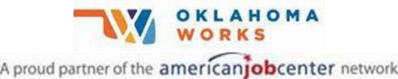

Equal opportunity employer/program. Auxiliary aids and services are available upon request to individuals with disabilities.
Training Provider Program Approval Period

Coffeyville Community College
Automotive Collision & Refinishing
Technology 6/21/2021-6/21/2023
Automotive Service Technology 6/21/2021-6/21/2023
Construction Technology 6/21/2021-6/21/2023
Electrical Technology 6/21/2021-6/21/2023
Medical Assistant 6/21/2021-6/21/2023
Precision Machining 6/21/2021-6/21/2022
Registered Nurse 9/14/2021-9/14/2023
Welding Technology 6/21/2021-6/21/2022

Crowder College
Transport Training 7/16/22-7/16/2023

Heavy Metal Training Institute
CDL Truck Driver Training 5/9/2022-5/9/2023

Northeast Tech
Anatomy & Physiology (AdultEd Afton) 5/10/2022-5/10/2023
Anatomy & Physiology (AdultEd Claremore) 5/10/2022-5/10/2023
Anatomy & Physiology (AdultEd Pryor) 4/19/2022-4/19/2024
Anatomy & Physiology (AdultEd Kansas) 7/7/2021-7/7/2023
Armed Private Security Phase IV
(AdultEd Afton) 6/30/2021-6/30/2023
Automotive Service Technician-M 2/1/2021-2/1/2023
AWS D1.1 Structural Welding Certification
(Adult Ed Pryor) 5/10/2022-5/10/2023
Basic Farm & Ranch Welding (Adult Ed Pryor) 5/10/2022-5/10/2023
Basic Tig & Pipe Welding (AdultEd Pryor) 2/1/2021-2/1/2023
Basic Welding GMAW (AdultEd Kansas) 1/21/2021-1/21/2023
Basic Welding GMAW (AdultEd Pryor) 4/1/2021-04/1/2023
Certified Billing & Coding Specialist-
(AdultEd Kansas) 6/30/2021-6/30/2023
Certified Phlebotomy Technician
(AdultEd Claremore) 6/10/2021-6/10/2022
Certified Medication Aide (AdultEd Afton) 7/19/2022-7/19/2023
Certified Medication Aide (AdultEd Pryor) 4/25/2022-4/25/2023
Certified Phlebotomy Technician
(AdultEd Pryor) 2/3/2021-2/3/2023
Certified Phlebotomy Technician
AdultEd Claremore) 7/15/2022-7/15/2023
Child Development Associate Training
(AdultEd Claremore) 7/17/2022-7/17/2023
CNA Long-Term Care (Adult/Evening) 5/10/22-5/10/2023
CNC (AdultEd Claremore) 6/8/2021-6/8/2022
CNC (Claremore Day Class) 6/8/2021-6/8/2022
CNC Machining (AdultEd Afton) 6/30/2021-6/30/2023
CNC Manufacturing Technician-M 2/1/2021-2/1/2023
Combination Collision Repair Technician-M 4/1/2021-4/1/2023
EMT Advanced (AdultEd Pryor) 4/1/2021-4/1/2023
EMT Basic (AdultEd Kansas) 6/30/2021-6/30/2022
EMT Basic (AdultEd Pryor) 7/16/2022-7/16/2023
Dental Assisting Foundations of (Afton) 4/28/2022-4/28/2023
Google IT Support Professional Certificate
(AdultEd Claremore) 6/17/2021-6/17/2022
Graphic Design Specialist 2/3/2021-2/3/2023
Home Health Care Aide (AdultEd Pryor) 5/10/2022-5/10/2023
Heating Ventilation & Air Conditioning
(BIS Pryor) 6/21/2021-6/21/2023
Long Term Care Aide (AdultEd Afton) 7/16/2022-7/16/2023
Long Term Care Aide (AdultEd Claremore) 5/10/2022-5/10/2023
Long Term Care Aide (AdultEd Kansas) 7/7/2021-7/7/2023
Long Term Care Aide (AdultEd Pryor) 5/10/2022-5/10/2023
Marine Repair Technician – M 6/9/2021-6/29/2023
Medical Terminology (AdultEd Afton) 5/10/2022-5/10/2023
Medical Terminology (AdultEd Claremore) 5/10/2022-5/10/2023
Medical Terminology (AdultEd Kansas) 7/7/2021-7/7/2023
Medical Terminology (AdultEd Pryor) 5/10/2022-5/10/2023
Nursing Assistant/Pre-Nursing 4/1/2021-4/1/2023
Nursing Concepts (AdultEd Afton) 5/10/2022-5/10/2023
Nursing Concepts (AdultEd Claremore) 5/10/2022-5/10/2023
Nursing Concepts (AdultEd Kansas) 1/21/2021-1/21/2023
Nursing Concepts (AdultEd Pryor) 7/16/2022-7/16/2023
Occupational Skills Training (Claremore) 12/8/2021 new
Office Specialist (AdultEd Claremore) 6/21/2021-6/21/2022
Paraprofessional Educator (AdultEd Afton) 6/30/2021-6/30/2023
Paraprofessional Educator (AdultEd Claremore) 7/18/2022-7/18/2024
Pharmacy Technician – M 4/1/2021-4/1/2023
Phlebotomy (AdultEd Kansas) 7/6/2021-7/6/2023
Phlebotomy (AdultEd Pryor) 7/16/2022-7/16/2023
Physical Therapy Aide – M 6/29/2021-6/29/2023
Pipe Welder – M 2/1/2021-2/1/2023
Practical Nursing 6/22/2021-6/22/2023
Private Security Phase III (AdultEd Afton) 4/1/2021-4/1/2022
Private Security Phase IV (AdultEd Pryor) 7/15/2022-7/15/2023
School Bus Driver Training
Structural Welder – M 7/29/2021-7/29/2023
TIG 5G & 6G Pipe Welding (AdultEd Pryor) 5/10/2022-5/10/2023
Truck Driver Training 2/17/2022-2/17/2023
Unarmed Security Phase I & II (AdultEd Afton) 4/19/2022-4/19/2024
Welder GMAW (AdultEd Afton) 5/10/2021-5/10/2023
Welding GTAW (AdultEd Afton) 5/10/2022-5/10/2023
Welder SMAW (Adult Ed Afton) 7/16/2022-7/16/2023

Northeastern OK A&M College
Medical Laboratory Technician 7/16/2022-7/16/2023
Physical Therapy Assistant 9/14/2021-9/14/2023

Northwest Arkansas Regional
Robotics Training Center
FCR-01 Fanuc Certified Robot Operator-1 7/16/2022-7/16/2023

Tri-County Technology Center
Accountant 7/13/2022-7/13/2023
Applied Welding Techniques 7/13/2022-7/13/2023
CompTIA A+ 7/16/2022-7/16/2023
CompTIA Network+ 7/16/2022-7/16/2023
Construction Technology 7/13/2022-7/13/2023
Emergency Medical Technician 7/15/2022-7/15/2023
Machine Tool Techniques 7/13/2022-7/13/2023
Medical Office Specialist 7/19/2022-7/19/2024
Networking Technology CompTIA
Network+ 8/10/2021-8/10/2023
Networking Technology CompTIA
A+ Certification 9/14/2021-9/14/2023
Paramedic 7/13/2022-7/13/2023
Practical Nursing 7/16/2022-7/16/2023

