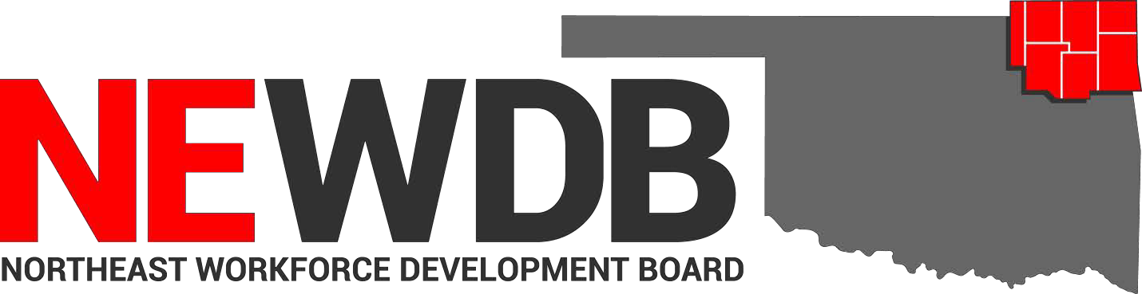
Updated 05.12.2021

Workforce Innovation and Opportunity Act Approved Training
Programs and Providers

No individual in the United States may, on the basis of race, color, religion, sex, national origin, age, disability, or political affiliation or belief, or, for beneficiaries, applicants, and participants only, on the basis of citizenship or participation in any WIOA Title I-financially assisted program or activity, be excluded from participation in, denied the benefits of, subjected to discrimination under, or denied employment in the administration of or in connection with any WIOA Title I- financially assisted program or activity.

Approved by: NEWDB Board Members Present 5.12.2021

Heather Smoot Date
Northeast Workforce Development Board Chair

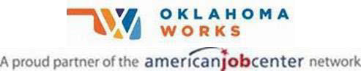
Equal opportunity employment/program. Auxiliary aids and services are available upon request to individuals with disabilities.

Nursing Asst/Pre-Nursing | Northeast Technology Center | 2/1/2021
Basic Welding-GMAW Adult Ed Pryor | Northeast Technology Center | 2/1/2021
EMT Advanced-Adult Ed Pryor | Northeast Technology Center | 2/1/2021
Pipe Welder-M | Northeast Technology Center | 2/1/2021
Welding-GMAW Adult Ed Afton | Northeast Technology Center | 2/1/2021
Basic TIG & Pipe Welding-Adult Ed Pryor | Northeast Technology Center | 2/1/2021
Automotive Service Technician-M | Northeast Technology Center | 2/1/2021
Pharmacy Tech-M | Northeast Technology Center | 2/1/2021
Graphic Design Specialist | Northeast Technology Center | 2/3/2021
Certified Phlebotomy Tech-Adult Ed Pryor | Northeast Technology Center | 2/3/2021
Transport Training | Crowder College | 10/15/2020
Networking Technology CompTIA Network+ | Tri County Technology Center | 6/17/2020
Networking Technology CompTIA A+ Cert | Tri County Technology Center | 6/17/2020
Emergency Medical Technician | Tri County Technology Center | 6/12/2020
Low Voltage Program Claremore | Northeast Technology Center | 6/2/2020
Private Security Phase III Adult Ed Afton | Northeast Technology Center | 2/1/2020
CNC Machining Adult Ed Afton | Northeast Technology Center | 1/21/2021
Armed Private Security Phase IV Adult Ed Afton | Northeast Technology Center | 1/21/2021
EMT Basic Adult Ed Kansas | Northeast Technology Center | 1/21/2021
Unarmed Security Phase I & II Adult Ed Afton | Northeast Technology Center | 9/14/2020
Welding GTAW Adult Ed Afton | Northeast Technology Center | 9/14/2020
Welding SMAW Adult Ed Afton | Northeast Technology Center | 9/14/2020
Certified Medication Aide Adult Ed Afton | Northeast Technology Center | 9/14/2020
Paraprofessional Educator Adult Ed Afton | Northeast Technology Center | 2/1/2021
Medical Terminology Adult Ed Afton | Northeast Technology Center | 9/14/2020
Certified Billing & Coding Specialist Adult Ed  Kansas | Northeast Technology Center | 1/21/2021
EMT Basic Adult Ed Afton | Northeast Technology Center | 9/14/2020
AWS D1.1 Structural Welding Cert Adult Ed  Pryor | Northeast Technology Center | 10/14/2020
TIG 5G & 6G Pipe Welding Adult Ed Pryor | Northeast Technology Center | 10/14/2020
Basic Farm & Ranch Welding Adult Ed Pryor | Northeast Technology Center | 10/14/2020
Basic Welding GMAW Adult Ed Kansas | Northeast Technology Center | 1/21/2021
Phlebotomy Adult Ed Kansas | Northeast Technology Center | 1/21/2021
CNC Programming Adult Ed Claremore | Northeast Technology Center | 10/14/2020
Paraprofessional Educator Adult Ed Claremore | Northeast Technology Center | 10/14/2020
Nursing Concepts Adult Ed Claremore | Northeast Technology Center | 10/14/2020
Anatomy & Physiology Adult Ed Claremore | Northeast Technology Center | 10/14/2020
Medical Terminology Adult Ed Claremore | Northeast Technology Center | 10/14/2020
Long Term Care Aide Adult Ed Claremore | Northeast Technology Center | 10/14/2020

Private Security Phase IV Adult Ed Pryor | Northeast Technology Center | 10/14/2020
Private Security Phase I & II Adult Ed Pryor | Northeast Technology Center | 10/14/2020
Medical Terminology Adult Ed Pryor | Northeast Technology Center | 10/14/2020
Nursing Concepts Adult Ed Pryor | Northeast Technology Center | 10/14/2020
Certified Medication Aide Adult Ed Pryor | Northeast Technology Center | 10/14/2020
Anatomy & Physiology Adult Ed Pryor | Northeast Technology Center | 10/14/2020
EMT Basic Adult Ed Pryor | Northeast Technology Center | 10/14/2020
Nursing Concepts Adult Ed Kansas | Northeast Technology Center | 1/21/2021
Long Term Care Aide Adult Ed Afton | Northeast Technology Center | 9/14/2020
Medical Terminology Adult Ed Kansas | Northeast Technology Center | 1/21/2021
Long Term Care Aide Adult Ed Kansas | Northeast Technology Center | 1/21/2021
Anatomy & Physiology Adult Ed Afton | Northeast Technology Center | 2/1/2021
Anatomy & Physiology Adult Ed Kansas | Northeast Technology Center | 1/19/2021
Home Health Care Aide Adult Ed Pryor | Northeast Technology Center | 10/14/2020
Long Term Care Aide Adult Ed Pryor | Northeast Technology Center | 10/14/2020
CDL Truck Driver Training | Heavy Metal Training Institute | 7/31/2019
Summer Welding Program | Northeast Technology Center | 2/1/2021
Phlebotomy Adult Ed Pryor | Northeast Technology Center | 10/14/2020
Phlebotomist | Northeast Technology Center | 9/14/2020
Machine Tool Techniques | Tri County Technology Center | 6/11/2020
Applied Welding Techniques | Tri County Technology Center | 6/11/2020
Medical Office Specialist | Tri County Technology Center | 6/11/2020
CNC Manufacturing Technician-M | Northeast Technology Center | 2/1/2021
Executive Administrative Assistant-M | Northeast Technology Center | 9/14/2020
Frame Carpenter-M | Northeast Technology Center | 9/14/2020
Combination Collision Repair Technician-M | Northeast Technology Center | 2/1/2021
Marine Repair Technician-M | Northeast Technology Center | 2/1/2021
Physical Therapy Aide-M | Northeast Technology Center | 2/1/2021
Physical Therapy Aide-M | Northeast Technology Center | 2/1/2021
Structural Welder-M | Northeast Technology Center | 2/1/2021
LPN to Associate Degree Nurse (RN) Fast Track  Program | NEO A&M College | 10/15/2020
Accounting | Tri County Technology Center | 6/11/2020
Construction Technology | Tri County Technology Center | 6/11/2020
Practical Nursing | Northeast Technology Center | 2/1/2021
Associate Degree Nursing-RN | NEO A&M College | 10/15/2019

