Revised 11.10.2021

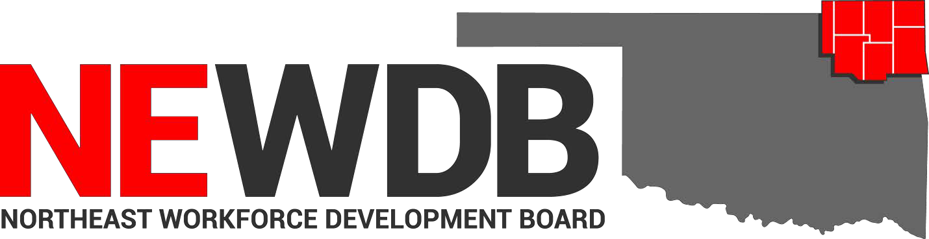

Workforce Innovation and Opportunity Act

Approved Training
Programs and Providers
No individual in the United States may, on the basis of race, color, religion, sex, national origin, age, disability, or political affiliation or belief, or, for beneficiaries, applicants, and participants only, on the basis of citizenship or participation in any WIOA Title I-financially assisted program or activity, be excluded from participation in, denied the benefits of, subjected to discrimination under, or denied employment in the administration of or in connection with any WIOA Title I- financially assisted program or activity.

Approved by: 11.10.2021 by NEWDB members present

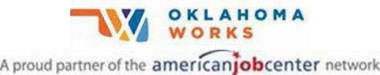

Equal opportunity employer/program. Auxiliary aids and services are available upon request to individuals with disabilities.

Training Provider Program Approval Date

Coffeyville Community College Automotive Collision Repair 6/21/2021
Automotive Service Technology 6/21/2021
Construction Technology 6/21/2021
Electrical Technology 6/21/2021
Medical Assistant 6/21/2021
Precision Machining 6/21/2021
Registered Nurse 8/8/2021
Welding Technology 6/21/2021

Crowder College Transport Training 11/4/2020

Heavy Metal Training Institute CDL Truck Driver Training 11/4/2020

Northeast Tech Anatomy & Physiology (AdultEd Afton) 2/10/2020
Anatomy & Physiology (AdultEd Claremore) 11/4/2020
Anatomy & Physiology (AdultEd Kansas) 7/7/2021
Anatomy & Physiology (AdultEd Pryor) 11/4/2020
Armed Private Security Phase IV
AdultEd Afton) 6/30/2021
Automotive Service Technician-M 2/1/2021
AWS D1.1 Structural Welding Certification
(AdultEd Pryor) 11/4/2020
Basic Farm & Ranch Welding (AdultEd Pryor) 11/4/2020
Basic Tig & Pipe Welding (AdultEd Pryor) 2/1/2021
Basic Welding GMAW (AdultEd Kansas) 1/21/2021
Basic Welding GMAW (AdultEd Pryor) 2/1/2021
Certified Billing & Coding Specialist
(AdultEd Kansas) 6/30/2021
Certified Medication Aide (AdultEd Afton) 2/10/2020
Certified Medication Aide (AdultEd Pryor) 11/4/2020
Certified Phlebotomy Technician
(AdultEd Claremore) 6/10/2021
Certified Phlebotomy Technician
(AdultEd Pryor) 2/3/2021
CNC (AdultEd Claremore) 6/8/2021
CNC (Claremore Day Class) 6/8/2021
CNC Machining (AdultEd Afton) 6/30/2021
CNC Manufacturing Technician-M 2/1/2021
CNC Programming (AdultEd Claremore) 11/4/2020
Combination Collision Repair Technician-M 4/1/2021
EMT Advanced (AdultEd Pryor) 4/1/2021
EMT Basic (AdultEd Afton) 10/1/2020
EMT Basic (AdultEd Kansas) 6/30/2021
EMT Basic (AdultEd Pryor) 11/4/2020
Executive Administrative Assistant-M 10/1/2020
Frame Carpenter-M 10/7/2020
Google IT Support Professional Certificate
(AdultEd Claremore) 6/17/2021
Graphic Design Specialist 2/3/2021
Heating Ventilation & Air Conditioning
(BIS Pryor) 6/21/2021
Long Term Care Aide (AdultEd Afton) 10/1/2020
Long Term Care Aide (AdultEd Claremore) 11/4/2020
Long Term Care Aide (AdultEd Kansas) 7/7/2021
Long Term Care Aide (AdultEd Pryor) 11/4/2020
Marine Repair Technician-M 6/29/2021
Medical Terminology (AdultEd Afton) 10/1/2020
Medical Terminology (AdultEd Claremore) 11/4/2020
Medical Terminology (AdultEd Kansas) 7/7/2021
Medical Terminology (AdultEd Pryor) 11/4/2020
Nursing Assistant/Pre-Nursing 4/1/2021
Nursing Concepts (AdultEd Afton) 10/1/2020
Nursing Concepts (AdultEd Claremore) 11/4/2020
Nursing Concepts (Adult Ed Kansas) 1/21/2021
Nursing Concepts (AdultEd Pryor) 11/4/2020
Office Specialist (AdultEd Claremore) 6/21/2021
Paraprofessional Educator (AdultEd Afton) 6/30/2021
Paraprofessional Educator
(AdultEd Claremore) 11/4/2020
Pharmacy Technician-M 4/1/2021
Phlebotomy (AdultEd Kansas) 7/6/2021
Phlebotomy (AdultEd Pryor) 11/4/2020
Phlebotomist 10/7/2020
Physical Therapy Aide-M 6/29/2021
Pipe Welder-M 2/1/2021
Practical Nursing 6/22/2021
Private Security Phase I & II (AdultEd Pryor) 11/4/2020
Private Security Phase III (AdultEd Afton) 4/1/2021
Private Security Phase IV (AdultEd Pryor) 11/4/2020
Structural Welder-M 6/29/2021
Summer Welding Program 7/7/2021
Unarmed Security Phase I & II (AdultEd Pryor) 10/1/2020
Welding GMAW (AdultEd Afton) 2/1/2021
Welding GTAW (AdultEd Afton) 10/1/2020
Welding SMAW (AdultEd Afton) 10/1/2020

Northeastern OK A&M College Associate Degree Nursing-RN 11/4/2020
LPN to Associate Degree (RN) Fast Track 11/4/2020
Medical Laboratory Technician 9/14/2021
Physical Therapy Assistant 9/14/2021

Tri-County Technology Center Accounting 1/7/2020
Applied Welding Techniques 1/7/2020
Construction Technology 1/7/2020
EMT 6/15/2020
Machine Tool Techniques 1/7/2020
Medical Office Assistant 1/7/2020
Networking Technology CompTIA
Network+ 6/22/2020
Networking Technology CompTIA
A+ Certification 6/22/2020

