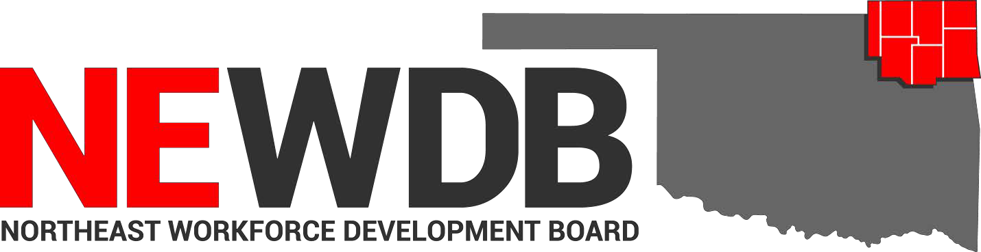

Workforce Innovation and Opportunity Act

Approved Training Programs
And Providers

No individual in the United States may, on the basis of race, color, religion, sex, national origin, age, disability, or political affiliation or belief, or, for beneficiaries, applicants, and participants only, on the basis of citizenship or participation in any WIOA Title I-financially assisted program or activity, be excluded from participation in, denied the benefits of, subjected to discrimination under, or denied employment in the administration of or in connection with any WIOA Title I- financially assisted program or activity.

Approved by:

NEWDB Members Present May 11, 2022

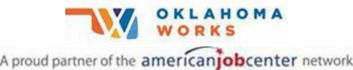

Equal opportunity employer/program. Auxiliary aids and services are available upon request to individuals with disabilities.
.
Training Provider Program Approval Period

Coffeyville Community College
Automotive Collision & Refinishing
Technology 6/21/2021-6/21/2023
Automotive Service Technology 6/21/2021-6/21/2023
Construction Technology 6/21/2021-6/21/2023
Electrical Technology 6/21/2021-6/21/2023
Medical Assistant 6/21/2021-6/21/2023
Precision Machining 6/21/2021-6/21/2022
Registered Nurse 9/14/2021-9/14/2023
Welding Technology 6/21/2021-6/21/2022

Crowder College
Transport Training 5/9/2022-5/9/2023

Heavy Metal Training Institute
CDL Truck Driver Training 5/9/2022-5/9/2023

Northeast Tech
Anatomy & Physiology (AdultEd Afton) 2/10/2020-2/10/2021
Anatomy & Physiology (AdultEd Claremore) 11/4/2020-11/4/2021
Anatomy & Physiology (AdultEd Kansas) 7/7/2021-7/7/2023
Anatomy & Physiology (AdultEd Pryor) 4/19/2022-4/19/2024
Armed Private Security Phase IV
(AdultEd Afton) 6/30/2021-6/30/2023
Automotive Service Technician-M 2/1/2021-2/1/2023
AWS D1.1 Structural Welding Certification
(AdultEd Pryor) 5/10/2022-5/10/2023
Basic Farm & Ranch Welding (AdultEd Pryor) 11/4/2020-11/4/2021
Basic Tig & Pipe Welding (AdultEd Pryor) 2/1/2021-2/1/2023
Basic Welding GMAW (AdultEd Kansas) 1/21/2021-1/21/2023
Basic Welding GMAW (AdultEd Pryor) 4/1/2021-04/1/2023
Certified Billing & Coding Specialist-
(AdultEd Kansas) 6/30/2021-6/30/2023
Certified Medication Aide (AdultEd Afton) 2/10/2020-2/10/2021
Certified Medication Aide (AdultEd Pryor) 4/25/2022-4/25/2024
Certified Phlebotomy Technician
(AdultEd Claremore) 6/10/2021-6/10/2022
Certified Phlebotomy Technician
(AdultEd Pryor) 2/3/2021-2/3/2023
CNA Long Term Care Aide 1/17/2019-1/17/2020
CNC (AdultEd Claremore) 6/8/2021-6/8/2022
CNC (Claremore Day Class) 6/8/2021-6/8/2022
CNC Machining (AdultEd Afton) 6/30/2021-6/30/2023
CNC Manufacturing Technician-M 2/1/2021-2/1/2023 CNC Programming (AdultEd Claremore) 11/4/2020-11/4/2021 Combination Collision Repair Technician-M 4/1/2021-4/1/2023
EMT Advanced (AdultEd Pryor) 4/1/2021-4/1/2023
EMT Basic (AdultEd Kansas) 6/30/2021-6/30/2022
EMT Basic (AdultEd Pryor) 11/4/2020-11/4/2021
Foundations of Dental Assisting (Afton) 4/28/2022-4/28/2023
Google IT Support Professional Certificate
(AdultEd Claremore) 6/17/2021-6/17/2022
Graphic Design Specialist 2/3/2021-2/3/2023
Heating Ventilation & Air Conditioning
(BIS Pryor) 6/21/2021-6/21/2023
Home Health Care Aide (AdultEd Pryor) 11/4/2020-11/4/2021
Long Term Care Aide (AdultEd Afton) 5/10/2022-5/10/2023
Long Term Care Aide (AdultEd Claremore) 5/10/2022-5/10/2023
Long Term Care Aide (AdultEd Kansas) 7/7/2021-7/7/2023
Long Term Care Aide (AdultEd Pryor) 5/10/2022-5/10/2023 Marine Repair Technician-M 6/29/2021-6/29/2023
Medical Terminology (AdultEd Afton) 5/10/2022-5/10/2023
Medical Terminology (AdultEd Claremore) 5/10/2022-5/10/2023
Medical Terminology (AdultEd Kansas) 7/7/2021-7/7/2023
Medical Terminology (AdultEd Pryor) 11/4/20920-11/4/2021
Nursing Assistant/Pre-Nursing 4/1/2021-4/1/2023
Nursing Concepts (AdultEd Afton) 10/1/2020-10/1/2021
Nursing Concepts (AdultEd Claremore) 5/10/2022-5/10/20223
Nursing Concepts (AdultEd Kansas) 1/21/2021-1/23/2023
Nursing Concepts (AdultEd Pryor) 11/4/2020-11/4/2021
Occupational Skills Training (Claremore) 12/8/2021 (new)
Office Specialist (AdultEd Claremore) 6/21/2021-6/21/2022
Paraprofessional Educator (AdultEd Claremore) 11/4/2020-11/4/2021
Pharmacy Technician-M 4/1/2021-4/1/2023
Phlebotomy (AdultEd Kansas) 7/6/2021-7/6/2023
Phlebotomy (AdultEd Pryor) 11/4/2020-11/4/2021
Physical Therapy Aide-M 6/29/2021-6/29/2023
Pipe Welder-M 2/1/2021-2/1/2023
Practical Nursing 6/22/2021-6/22/2023
Private Security Phase III (AdultEd Afton) 4/1/2021-4/1/2022
Private Security Phase IV (AdultEd Pryor) 11/4/2020-11/4/2021
Structural Welder-M 6/29/2021-6/29/2023
Summer Welding Program 7/7/2021-7/7/2022
TIG 5G & 6G Pipe Welding (AdultEd Pryor) 11/4/20-11/4/2021
Truck Driver Training 2/17/2022-2/17/2023
Unarmed Security Phase I & II (AdultEd Afton) 4/19/2022-4/19/2024
Unarmed Security Phase I & II (AdultEd Pryor) 11/4/2020-11/4/2021
Welding GMAW (AdultEd Afton) 2/1/2021-2/1/2023
Welding SMAW (AdultEd Afton) 10/1/2020-10/1/2021

Northeastern OK A&M College
Medical Laboratory Technician 9/14/2021-9/14/2023
Physical Therapy Assistant 9/14/2021-9/14/2023

Tri-County Technology Center
Networking Technology CompTIA
Network+ 8/10/2021-8/10/2023
Networking Technology CompTIA
A+ Certification 9/14/2021-9/14/2023
Practical Nursing 9/14/2021-9/14/2023

