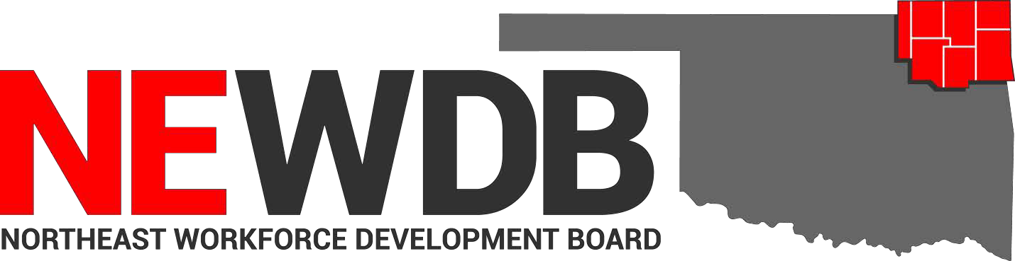
Updated 08.11.2021

Workforce Innovation and Opportunity Act Approved Training
Programs and Providers

No individual in the United States may, on the basis of race, color, religion, sex, national origin, age, disability, or political affiliation or belief, or, for beneficiaries, applicants, and participants only, on the basis of citizenship or participation in any WIOA Title I-financially assisted program or activity, be excluded from participation in, denied the benefits of, subjected to discrimination under, or denied employment in the administration of or in connection with any WIOA Title I- financially assisted program or activity.

Approved by:
NEWDB at the meeting held 8.11.2021

Heather Smoot Date
Northeast Workforce Development Board Chair

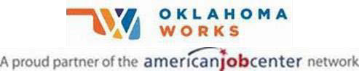
Equal opportunity employment/program. Auxiliary aids and services are available upon request to individuals with disabilities.

Training Provider  Coffeyville Community College | Program  Registered Nurse | Approval Date  8/8/2021
 | Precision Machining | 6/21/2021
 | Automotive Service Technology | 6/21/2021
 | Construction Technology | 6/21/2021
 | Medical Assistant | 6/21/2021
 | Welding Technology | 6/21/2021
 | Electrical Technology | 6/21/2021
 | Automotive Collision Repair | 6/21/2021
Crowder College | Transport Training | 11/4/2020
Heavy Metal Training Institute | CDL Truck Driver Training | 11/4/2020
NE Technology Center | Anatomy & Physiology (AdultEd Kansas) | 7/7/2021
 | Medical Terminology (AdultEd Kansas) | 7/7/2021
 | Summer Welding Program | 7/7/2021
 | Certified Medication Aide (AdultEd Pryor) | 11/4/2020
 | EMT Basic (AdultEd Pryor) | 11/4/2020
 | Long Term Care Aide (AdultEd Pryor) | 11/4/2020
 | Unarmed Security Phase I & II (AdultEd Pryor) | 10/1/2020
 | Phlebotomy (AdultEd Kansas) | 7/6/2021
 | Private Security Phase III (AdultEd Afton)  Armed Private Security Phase IV (AdultEd Afton) | 4/1/2021  6/30/2021
 | EMT Basic (Adult Ed Kansas) | 6/30/2021
 | TIG 5G & 6G Pipe Welding (AdultEd Pryor) | 11/4/2020
 | Basic Farm & Ranch Welding (AdultEd Pryor) | 11/4/2020
 | Welding GTAW (AdultEd Afton) | 10/1/2020
 | Welding SMAW (AdultEd Afton) | 10/1/2020
 | Certified Medication Aide (AdultEd Afton) | 2/10/2020
 | Nursing Concepts (AdultEd Afton) | 10/1/2020
 | Medical Terminology (AdultEd Afton) | 10/1/2020
 | EMT Basic (AdultEd Afton)  AWS D1.1 Structural Welding Certification (AdultEd Pryor) | 10/1/2020  11/4/2020
 | Basic Welding GMAW (AdultEd Kansas) | 10/14/2019
 | CNC Programming (AdultEd Claremore) | 11/4/2020
 | Nursing Concepts (AdultEd Claremore) | 11/4/2020
 | Anatomy & Physiology (AdultEd Claremore) | 11/4/2020
 | Medical Terminology (AdultEd Claremore) | 11/4/2020
 | Private Security Phase IV (AdultEd Pryor) | 11/4/2020
 | Private Security Phase I & II (AdultEd Pryor) | 11/4/2020
 | Medical Terminology (AdultEd Pryor) | 11/4/2020
 | Nursing Concepts (AdultEd Pryor) | 11/4/2020

NE Technology Center
Anatomy & Physiology (AdultEd Pryor) | 11/4/2020
Nursing Concepts (AdultEd Kansas) | 10/15/2019
Long Term Care Aide (AdultEd Afton) | 10/1/2020
Long Term Care Aide (AdultEd Kansas) | 7/7/2021
Anatomy & Physiology (AdultEd Afton) | 2/10/2020
Frame Carpenter-M | 10/7/2020
Marine Repair Technician-M | 6/29/2021
Combination Collision Repair Technician-M | 4/1/2021
Phlebotomy (AdultEd Pryor) | 11/4/2020
Phlebotomist | 10/7/2020
CNC Manufacturing Technician-M | 11/13/2019
Executive Administrative Assistant-M | 10/1/2020
Physical Therapy Aide-M | 6/29/2021
Structural Welder-M | 6/29/2021
Certified Phlebotomy Technician
(AdultEd Claremore) | 6/10/2021
CNC Machining ((AdultEd Afton) | 6/30/2021
Office Specialist (AdultEd Claremore) | 6/21/2021
Certified Billing & Coding Specialist
(AdultEd Kansas) | 6/30/2021
Long Term Care Aide (AdultEd Claremore) | 11/4/2020
Paraprofessional Educator
(AdultEd Claremore) | 11/4/2020
Google IT Support Professional Certificate
(AdultEd Claremore) | 6/17/2021
CNC (AdultEd Claremore) | 6/8/2021
Practical Nursing | 6/22/2021
Basic Welding GMAW (AdultEd Pryor) | 4/1/2021
EMT Advanced (AdultEd Pryor) | 4/1/2021
Nursing Assistant/Pre-Nursing | 4/1/2021
Pipe Welder-M | 2/1/2021
Basic TIG & Pipe Welding (AdultEd Pryor) | 2/1/2021
Automotive Service Technician-M | 2/1/2021
Pharmacy Technician-M | 4/1/2021
Graphic Design Specialist | 2/3/2021
Certified Phlebotomy Technician
(AdultEd Pryor) | 2/3/2021
Heating Ventilation & Air Conditioning
(BIS Pryor) | 6/21/2021
CNC (Claremore Day Class) | 6/8/2021
Welding GMAW (AdultEd Afton) | 2/1/2021
Paraprofessional Educator (AdultEd Afton) | 6/30/2021

Northeastern OK A&M College | Medical Laboratory Technician | 6/5/2019
 | Associate Degree Nursing-RN  LPN to Associate Degree (RN) Fast Track Program | 11/4/2020  11/4/2020
 | Physical Therapist Assistant | 1/6/2020
Tri-County Technology Center | Networking Technology CompTIA Network+ | 6/22/2020
 | Networking Technology CompTIA
A+ Certification |  | 6/22/2020
EMT |  | 6/15/2020
Practical Nursing |  | 1/7/2020
Construction Technology |  | 1/7/2020
Accounting |  | 1/7/2020
Practical Nursing |  | 1/7/2020
Machine Tool Techniques |  | 1/7/2020
Applied Welding Techniques |  | 1/7/2020
Medical Office Assistant |  | 1/7/2020

