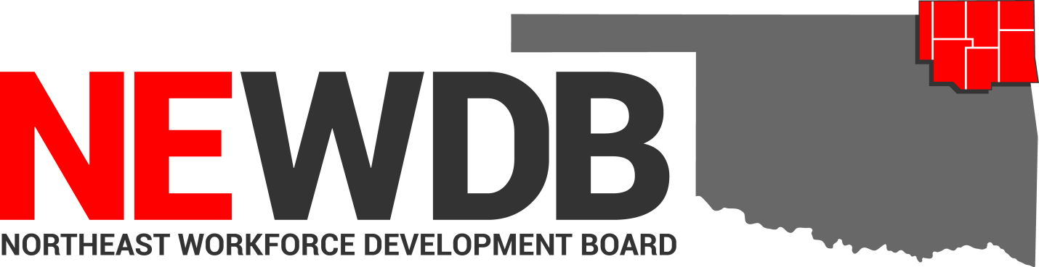
  - Workforce Innovation and Opportunity Act

Self-Sufficiency Policy
No individual in the United States may, on the basis of race, color, religion, sex, national origin, age, disability, or political affiliation or belief, or, for beneficiaries, applicants, and participants only, on the basis of citizenship or participation in any WIOA Title I-financially assisted program or activity, be excluded from participation in, denied the benefits of, subjected to discrimination under, or denied employment in the administration of or in connection with any WIOA Title I-financially assisted program or activity.
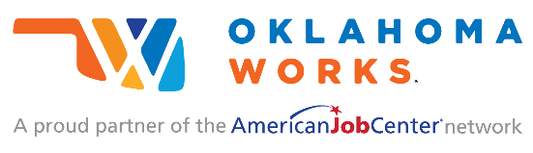
Equal opportunity employment/program. Auxiliary aids and services are available upon request to individuals with disabilities.

Self-Sufficiency Policy

I. PURPOSE:
This policy establishes a self-sufficiency standard of $13.08 (Adult) and $16.35 (Dislocated Worker) earned wages per hour to determine eligibility for employed registrants requesting Intensive and Training services under Title I of the Workforce Innovation and Opportunity Act (WIOA). This standard applies to both adults and dislocated workers, who are employed at the time of enrollment. This policy outlines the procedure, and defines the self-sufficiency wage standard and related acceptable documentation. This policy is established in accordance with the Oklahoma Office of Workforce Development (OOWD), WIOA and any other applicable laws, rules, regulations and requirements.

II. BACKGROUND:
The Workforce Innovation and Opportunity Act (WIOA) requires that in the event funds allocated to a local region are used to provide career and training services for employed workers, the Local Board must establish a self-sufficiency wage standard which is to be used in determining the eligibility of the employed worker. At a minimum, such criterion must provide self-sufficiency means employment that pays at least lower living standard income level, as defined in WIOA section 134(3).
Legal Use of Federal Funds: WIOA funds may not be used to help participants or employers to fill positions or provide support for employment that promotes or supports the use, possession or distribution of marijuana.

III. REFERENCES:
- The Workforce Innovation and Opportunity Act (WIOA), Section 3 (36) (A) (II) Low Income Level;
- Section 134 (a)(3)(A)(xii)
- WIOA Section 134 (c)(3)(H)
- OWDI #08-2018
- Federal Register, 20 CFR, 663.220 and 663.230
- Memo 02-2020: NEWDB Priority of Service; Category 4 and 5

IMPORTANT! This document contains important information about your rights, responsibilities and/or benefits. It is critical that you understand the information in this document, and we will provide the information in your preferred language at no cost to you. Call Jeremy Frutchey 405.269.2821

IMPORTANTE! Este document contiene información sobre sus derechos, responsabilidades y/o beneficios. Es importante que usted entienda la información en este documento. Nosotros le podemos ofrecer la información en el idioma de su preferencia sin costo para usted. Llame al Jeremy Frutchey 405.269.2821 para pedir asistencia en traducir y entender la información en este documento.

BABEL NOTICE: (29CFR 38.9(g)(3)): This document contains vital service information. If English is not your preferred language, please contact:

Northeast Workforce Development Board
Jeremy Frutchey, EO Officer
5238 N Highway 167
Catoosa, OK 74015
Phone: 918.907.0902 or Cell: 405.269.2821
Email: jeremy.frutchey@northeastworkforceboard.com

Or,

Equal Opportunity Officer
Oklahoma Office of Workforce Development
Ferris Barger
900 N Portland Avenue, BT 300
Oklahoma City, OK 73107
Office: 405.208.2519
Email: ferris.barger@okcommerce.gov

To enable telephone conversation between people with speech or hearing loss and people without speech or hearing loss please call Oklahoma Relay at 711 (http://www.oklahomarelay.com/711.html) or TDD/TTY: 800-722-0353.

IV. POLICY

The NEWDB Self-Sufficiency Policy establishes the wage standards for training opportunities that leads to self-sufficiency. The self-sufficiency wage standard is intended to allow the Northeast Workforce Development Board to:

• Extend services to low-income workers and place them on a path to self-sufficiency.
• Target high-wage industry sectors of the economy and occupations for training,
apprenticeships, and in developing customized training programs.
• Offer training in occupations with career ladders that lead to self-sufficiency.

NEWDB’s Self-Sufficiency Policy defines Self-Sufficiency, as of the date of this memo, as:

- Wage
The self-sufficiency threshold for the Northeast Workforce Development Area (NEWDA) is $13.08 per hour for registrants requesting career and training services under WIOA. This threshold applies to all employed registrants, both Adult and Dislocated Workers.

Definition
Self-sufficiency wage is defined as employment that provides a wage equal to or greater than 200% LLSIL for Adult participants and 250% For Dislocated Worker participants. The self-sufficiency wage standard is updated annually based on the most recent LLSIL data.

- Self-sufficiency Wage Calculation Methodology
The calculation methodology is determined based on a percent of the Lower Living Standard Income Levels (LLSIL), as outlined in the most current guidance from the OOWD:
- 200% LLSIL for Adult
- 250% LLSIL for Dislocated Worker

Note: review the most recent Self-Sufficiency Policy and LLSIL in order to identify the most recent income caps.

Wage at Enrollment Documentation:
The following items must be documented in order to validate the participant is not earning a self-sufficient wage:
- For employed individuals not earning a self-sufficient wage at the time of enrollment:
  - The participant’s most recent pay-stub must be uploaded, with their “WIOA Adult and Dislocated Worker Eligibility Form” demonstrating that the participants earned, normal wage, is less than the NEWDB Self-Sufficient wage.
- For employed individuals whose Family Size & Income does not meet the Self-Sufficient definition:
- “The participant’s WIOA Income Eligibility Form: Part I and Part II” from OWDI 02-2019 Attachment A, must be uploaded along with the income and supporting documents for each family member in the household; along with the “WIOA Adult and Dislocated Worker Eligibility Form”.
- Instructions on completing the WIOA Income Eligibility forms are provided in OWDI 02-2019 Attachment A.

Exceptions to Definition:
The special needs of individuals with disabilities or other barriers to employment require special consideration when determining employment that leads to self-sufficiency. OJM Program Case Notes must be used to explain and justify such consideration if, because of a barrier, the projected annual wage for the identified employment goal falls below $26,300 for Adult and $32,885 for Dislocated Worker. The following source documentation may be used to document a disability or other significant barrier:
- Medical records or doctor statement
- IEP from school
- Public assistance records verifying eligibility for SSI
- Social Security notice verifying eligibility for disability
- Statement from Rehabilitative Services
- Applicant statement
- Telephone Verification

V. EQUAL OPPORTUNITY AND NONDISCRIMINATION STATEMENT:
All Recipients, and Sub recipients/Sub grantees must comply with WIOA’s Equal Opportunity and Nondiscrimination provisions which prohibit discrimination on the basis of race, color, religion, sex (including pregnancy, childbirth, and related medical conditions, transgender status, and gender identity), national origin (including limited English proficiency), age, disability, political affiliation or belief, or, for beneficiaries, applicants, and participants only, on the basis of citizenship status or participation in a WIOA Title-I financially assisted program or activity.

VI. POLICY ADDITIONS AND CLARIFICATIONS:
The NEWDB Executive Director is authorized to issue additional instructions, guidance, approvals, forms, etc. to further implement the requirements of this policy.

Approved by NEWDB 5/12/2021

__________________________________________ ___________________
Heather Smoot, Chair Date
Northeast Workforce Development Board

