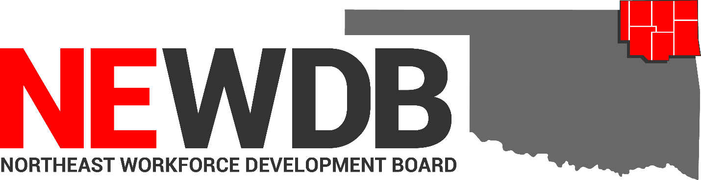

Workforce Innovation and Opportunity Act

Firewalls and Conflict of Interest Agreement

No individual in the United States may, on the basis of race, color, religion, sex, national origin, age, disability, or political affiliation or belief, or, for beneficiaries, applicants, and participants only, on the basis of citizenship or participation in any WIOA Title I-financially assisted program or activity, be excluded from participation in, denied the benefits of, subjected to discrimination under, or denied employment in the administration of or in connection with any WIOA Title I-financially assisted program or activity.

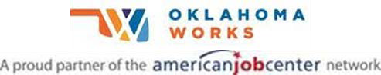

Equal opportunity employer/program
Auxiliary aids and services are available upon request to individuals with disabilities

Firewalls and Conflict of Interest Agreement

I. PURPOSE:
The purpose of this policy is to provide guidance and establish the Northeast Workforce Development Board (NEWDB) Firewalls and Conflict of Interest Agreement. A conflict of interest can arise when actions are taken or may appear to be taken by entity involved in more than one role, such that the performance of that entity in one role affects its interest in its other role, thereby making it difficult for the entity to perform the procurement process objectively and impartially. Therefore, proper firewalls must be in place to ensure the transparency and integrity of the procurement process and demonstrate to the public and to the oversite entities, that the selection process was impartial and that no preferential treatment was given to the awardee.

II. BACKGROUND:
Local organizations often function simultaneously in a variety of roles, including local fiscal agent, local Workforce Development Board (WDB) staff, one stop operator, and direct provider of services. Any organization that has been selected or otherwise designated to perform more than one of these functions must develop a written agreement with the Local WDB and Local Elected Official to clarify how the organization will carry out its responsibilities while demonstrating compliance with WIOA and corresponding regulations, relevant Office of Management and Budget circulars, and the State's conflict of interest policy.

III. REFERENCES:
WIOA sec. 121(d)(4)(A)
WIOA CFR 20 679.430
WIOA sec. 107(h
20 CFR 679.430
20 CFR 678.610(c)
2 CFR 200.319(a)
TEGL 15-16
OWDI #23-2017 Change 1

BABEL NOTICE: (29CFR 38.9(g)(3)): This document contains vital service information. If English is not your preferred language, please contact:

Northeast Workforce Development Board
Jeremy Frutchey, EO Officer
5238 OK Hwy 167
Catoosa, OK 74015
Phone: 918.907.0902 or Cell: 405.269.2821
Email: jeremy.frutchey@northeastworkforceboard.com

or,

State Equal Opportunity Officer
Oklahoma Office of Workforce Development
Ferris Barger
900 N Portland Avenue, BT 300
Oklahoma City, OK 73107
Office: 405.208.2519
Email: Ferris.barger@okcommerce.gov

To enable telephone conversation between people with speech or hearing loss and people without speech or hearing loss please call Oklahoma Relay at 711 (http://www.oklahomarelay.com/711.html) or TDD/TTY: 800-722-0353.

IV. Firewalls and Conflict of Interest Agreement
As the administrative and financial entity designated by the NEWDB, it is common to serve more than one role within the one-stop delivery system. In such circumstances the possibility that a conflict of interest may arise is inherent when the administrative and financial entity are performing, or seeking to perform, multiple functions within the workforce development system.

Consistent with WIOA sec. 121(d)(4)(A), NEWDB members and staff must disclose any real or apparent conflict of interest, whether individual, or organizational. NEWDB written standards of conduct identify the process for recusal of individuals or organizations that are members of the NEWDB who disclose a real or apparent conflict of interest.

As specified in 20 CFR 678.610(c) and in conformity with 20 CFR 679.430 for demonstrating internal controls and preventing conflict of interest, the NEWDB written standards of conduct include a description of the use of firewalls to mitigate conflict of interest in circumstances including, but not limited to, situations where the administrative or financial entity acts in more than one role in the one-stop delivery system or performs more than one function in the procurement process, as well as situations where the non-Federal entity uses a sole source selection.

- Recusal of Members of the NEWDB
Consistent with the NEWDB’s Conflict of Interest policies and WIOA sec. 107(h), under competitive procurement requirements, when the NEWDB, acting in its administrative or financial capacity, is also the offeror of one stop operator services, the NEWDB must recuse staff and NEWDB members who have conflicts of interest from the one-stop operator competition. This includes individuals with financial or other interests in the entities applying to be the one stop operator. Recusal of staff and NEWDB members with conflicts of interest demonstrates the NEWDBs transparency and efforts to avoid conflicts of interest when a small number of decision makers have conflicts of interest.

- Use of Firewalls

- Outsourcing
The NEWDB has established firewalls that include, the requirement that the NEWDB will contract with a separate and independent outside entity to conduct the competitive procurement process. Outsourcing the entire process (including development of requirements, drafting the RFP, evaluation of proposals/bids, and identification of best entity) to an alternate entity is required to effectively demonstrate the transparency of the process and to ensure a fair and competitive process.

- Exclusion of Staff and NEWDB Members
No entity or individual that develops or drafts specifications, requirements, statements of work, IFBs or RFPs, and evaluation of proposals may compete under that procurement (2 CFR 200.319(a).

- One Stop Operator
The One Stop Operator is prohibited from the following activities:
- Convene system stakeholders to assist in the development of the Local plan;
- Prepare and submit Local plans;

Under WIOA the One Stop Operator is prohibited from:
- Oversight of the one stop operator(s);
- Management of the competitive selection process for one-stop operators;
- Selection or termination of one stop operators, career services, and youth providers;
- Negotiation of local performance accountability measures; and
- Development and submission of budgets for activities of the NEWDB.

And to these prohibitions is when the entity serving as the one-stop operator is also serving in a different role within the one stop delivery system. In such an instance, the one stop operator may perform some or all of these functions when it is acting in its other role, and in accordance with established firewalls and conflict of interest policies and procedures.

The One Stop Operator must disclose to the NEWDB and Chief Local Elected Official, in writing, any potential conflicts of interest arising from serving in more than one role within the one stop delivery system.

- Monitoring and Oversite

- Annual Monitoring Requirements
The NEWDB will ensure the One Stop Operator is monitored annually with the following minimum monitoring requirements:

- Performance of each contractually required OSO function; and
- OSO expenditures, to ensure they are within budget and are reasonable, necessary, and allowable in accordance with the Uniform Guidance

- Independent Monitoring Process
The NEWDB will coordinate with a separate and independent outside entity for annual monitoring of the One Stop Operator if the NEWDB is acting as the One Stop Operator.

Approved by NEWDB Executive Committee

Heather Smoot Date: 2/11/2021
Northeast Workforce Development Board Chair

