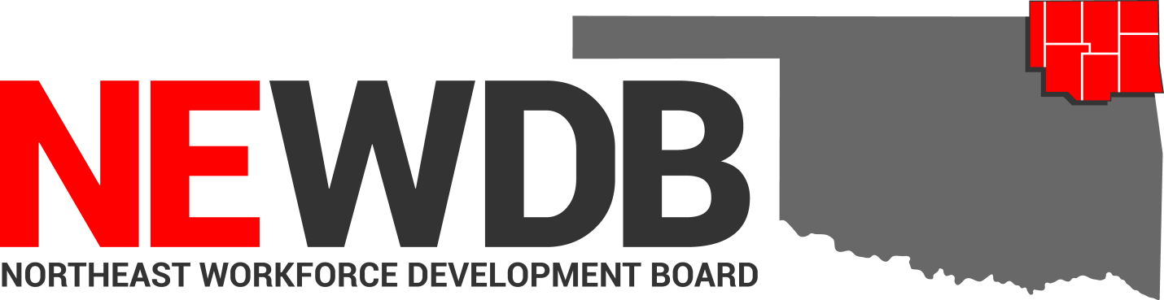
  - Workforce Innovation and Opportunity Act

Record Retention Policy
No individual in the United States may, on the basis of race, color, religion, sex, national origin, age, disability, or political affiliation or belief, or, for beneficiaries, applicants, and participants only, on the basis of citizenship or participation in any WIOA Title I-financially assisted program or activity, be excluded from participation in, denied the benefits of, subjected to discrimination under, or denied employment in the administration of or in connection with any WIOA Title I-financially assisted program or activity. 11
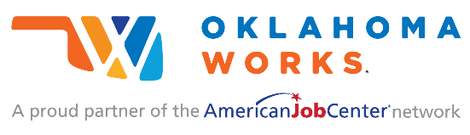
Equal opportunity employment/program. Auxiliary aids and services are available upon request to individuals with disabilities.

Record Retention Policy

I. PURPOSE:
The purpose of this policy is to provide guidance and establish the Northeast Workforce Development Boards (NEWDB) standards ensure that all subgrantee and administrative staff retain all records relative to all grants and agreements under the Workforce Innovation and Opportunity Act (WIOA) for an amount of time adequate to meet the requirements prescribed by statute and program regulation. Financial, statistical, property and participant records are all subject to record retention requirements. This policy is established in accordance with WIOA, the Oklahoma Office of Workforce Development (OOWD), and other applicable State and Federal laws, rules and regulations.

II. BACKGROUND:
WIOA Section 185(a)(1) and (f) require that procedures be developed to ensure proper retention of all records pertinent to all grants and agreements under the Workforce Innovation and Opportunity Act (WIOA). 29 CFR 38.43 (a) outlines that each recipient must maintain the following records, whether they exist in electronic form (including email) or hard copy, for a period of not less than three years from the close of the applicable program year: (1) The records of applicants, registrants, eligible applicants/registrants, participants, terminees, employees, and applicants for employment.

Legal Use of Federal Funds: WIOA funds may not be used to help participants or employers to fill positions or provide support for employment that promotes or supports the use, possession or distribution of marijuana.

III. REFERENCES:
- WIOA Section 185(a)(1), (f)(1-2)
- 2 CFR Part 200, Uniform Administrative Requirements
- 29 CFR 38.43 (a)
- NEWDB Fiscal Policy
- NEWDB Nondiscrimination and EO Policy
- PY 2019 Monitoring - OOWD

BABEL NOTICE: (29CFR 38.9(g)(3)): This document contains vital service information. If English is not your preferred language, please contact:

Northeast Workforce Development Board
Jeremy Frutchey, EO Officer
1503 N Lynn Riggs Blvd, Ste. D
Claremore, OK 74017
Cell: 405-269-2821
Email: jeremy.frutchey@northeastworkforceboard.com

Or,

Equal Opportunity Officer
Oklahoma Office of Workforce Development
Ferris Barger
900 N Portland Avenue, BT 300
Oklahoma City, OK 73107
Office: 405.208.2519
Email: ferris.barger@okcommerce.gov

To enable telephone conversation between people with speech or hearing loss and people without speech or hearing loss please call Oklahoma Relay at 711 (http://www.oklahomarelay.com/711.html) or TDD/TTY: 800-722-0353. normal

IV. POLICY
The Policy contains the requirements and procedures for the retention of documents. The Policy is designed to ensure compliance with federal and state laws and regulations, to promote efficiency in record keeping and to protect against accidental destruction of records.

Procedure:
All subgrantees, service providers, and administrative entity staff shall retain all records pertinent to all grants, contract and agreements under the WIOA including financial, statistical, property, participant records, and supporting documentation for a period of three (3) years from the date the NEWDB receives the final expenditure report for that program year. If at the end of three years there is ongoing litigation or an audit involving records, the records shall be retained until resolution of the litigation or audit.
Procedures are as follows:
- All registration documents including signed WIOA application, service-related forms, and/or other documents produced during the time of registration and participation must be uploaded into OKJobMatch at the time of completion, with the exception of private medical and disability-related documents.

- All confidential medical information must be kept in a separate, secure location with access limited only to staff who are providing direct case management or to staff who are verifying eligibility-based information in the secure file. (e.g., secured filing cabinets and/or encrypted Internet files). 29 C.F.R. §§ 38.41-38.45. Medical and/or disability-related information is not be kept in the participant’s program file; rather, only the accommodation requested, if any, is maintained in the participant’s file. Documents provided by a participant containing confidential medical or disability related information should be used only as a validating document for case managers to verify at the time of service and destroyed once validated. Where self-attestation is required, the attestation form must be uploaded in OKJobMatch.

- Prior to the destruction of any records, a written request to carry out the destruction of records must be reviewed and approved by the NEWDB.

- Upon receipt of written authorization from the NEWDB Executive Director, records may be destroyed or surrendered to the administrative entity, the NEWDB.

VI. EQUAL OPPORTUNITY AND NONDISCRIMINATION STATEMENT:
All Recipients, and Sub recipients/Sub grantees must comply with WIOA’s Equal Opportunity and Nondiscrimination provisions which prohibit discrimination on the basis of race, color, religion, sex (including pregnancy, childbirth, and related medical conditions, transgender status, and gender identity), national origin (including limited English proficiency), age, disability, political affiliation or belief, or, for beneficiaries, applicants, and participants only, on the basis of citizenship status or participation in a WIOA Title-I financially assisted program or activity.

VI. POLICY ADDITIONS AND CLARIFICATIONS:
The NEWDB Executive Director is authorized to issue additional instructions, guidance, approvals, forms, etc. to further implement the requirements of this policy.

Approved by NEWDB May 15, 2020:

