NEWDB MEMO 01-2020
Date: March 24, 2020
To: Odle Management Group
From: NEWDB
Subject: CoVid-19 Enrollment Procedures

Message
The procedures outlined in this memo are reflective of procedures provided by OOWD in TA 01-2020, and effective immediately. These procedures will only be in effect until normal operations of the American Job Centers have been resumed.

Technology Resources
The resources below may be utilized as tools for virtual communications.
- Google Voice - https://voice.google.com/u/0/calls - Provides a free “alternate” phone number that can be utilized via internet web browser or cell phone. This enables contact with clients via text-messaging in a way that does not utilize staff’s personal phone number.
- Tiny Scanner – see here for Apple; see here for Android; Tiny Scanner enables staff or clients to take a picture of a document and convert the picture into a PDF. This is a free app on both the Android and Apple platforms.

Security
Documents with identifying information for participants must be transmitted in a secure way. This security will be ensured by the following processes:
- CM will inform client via phone call and email that:
  - The information they are sending, such as their Eligible to Work documents and their Demographic Snapshot information contains personally identifiable information;
  - This sending and receiving of this information relies on basic email security, and is not encrypted;
  - The participant informs the Case Manager that they are aware of the risks associated with transmitting this information via email or text message, and grants consent.
  - Verification of this message will be uploaded by uploading the “Sent” email provided to participants. Additionally, the participant’s demographic snapshot must also be uploaded.

Process Requirements
During the time that these processes are in place, NEWDB requires the following actions take place to ensure oversight occurs as these uncharted processes roll out:
- A list of new enrollments will be submitted to NEWDB’s Compliance Monitor daily.
- A list of requests for Supportive Services or Training Resources will be submitted to NEWDB’s Compliance monitor by COB the date that the request from a client takes place. A list of on-going requests will be created by the Service Provider in Drop Box and shared with NEWDB.

Adult & Dislocated Worker Customers
OOWD has outlined in TA 01-2020 the following items to allow new enrollments and IEPs for Adults and DLW customers:
- For the collection of Eligibility Documentation:
  - Eligibility documents may be sent to Case Manager via email via a secure email, regular mail, or mobile snapshot.
- For entering a demographic snapshot:
  - The Case Manager will review the information located in the Demographic Snapshot with the client over the phone. No digital signature will be entered when opening the enrollment.
  - The Demographic Snapshot will be emailed, or sent by mobile snapshot to the client.
  - The client will then complete a virtual/digital signature to attest to the accuracy of the information in the demographic snapshot.
  - The signed Demographic Snapshot will then be returned to the Case Manager via email, or mobile snapshot.
  - The enrollment may only be created after receiving the signed demographic snapshot details from the participant.
  - The signed Demographic Snapshot must be uploaded into Oklahoma Job Match in the Enrollment Uploads
  - A program note must be entered documenting that all of the above processes have taken place.
- For creating an IEP:
  - The IEP will be developed over the phone with the client.
  - The IEP will be entered into OK Job Match.
  - A copy of the IEP will then be sent to the client via email, or mobile snapshot.
  - The participant will sign and return the IEP via email, or mobile snapshot.
  - Once received by the CM, the signed IEP will be uploaded into the participants Enrollment Uploads.
  - A program note will be entered documenting that all of the above processes have taken place.
- For other documents and documents requiring signatures:
  - Any additional documentation needs that would normally require signatures may be sent to a client via email, mail or mobile snapshot. Normal documentation requirements are still in effect. Requests for a variation of documentation requirements due to causing undue hardships on participants will be evaluated on a case-by-case basis by submitting a request to NEWDB.
  - Clients will complete documents required for enrollments, ITA’s, Training Vouchers, Supportive Services, etc.; and return the documents to Case Managers via mail, email or mobile snapshot.
  - Documents will be uploaded per normal upload requirements.
  - A program note will be entered detailing how required documents were obtained from participants or other required parties (i.e.: landlords, training providers, vendors for supportive services, etc.).

Youth Services
- Documentation of Youth Eligibility:
  - All efforts must be taken do document eligibility for youth services, via 3rd party documentation, in alignment with OWDI 02-2019. In the event that documentation cannot be attained to support eligibility, a Client Self-Attestation may be used to support eligibility for services. In order to document the self-attestation of eligibility, the following items must occur:
    - The client must submit a signed or digitally signed document attesting to eligibility barrier status and school status (such as pregnant, parenting, offender, etc.).
    - The signed document must be uploaded into the participant’s OK Job Match enrollment uploads.
    - A program note must be entered detailing efforts taken to validate participant’s eligibility barriers.
  - OOWD, in Memo 01-2020 outlines the following as it relates to documentation of Youth Eligibility:
    - 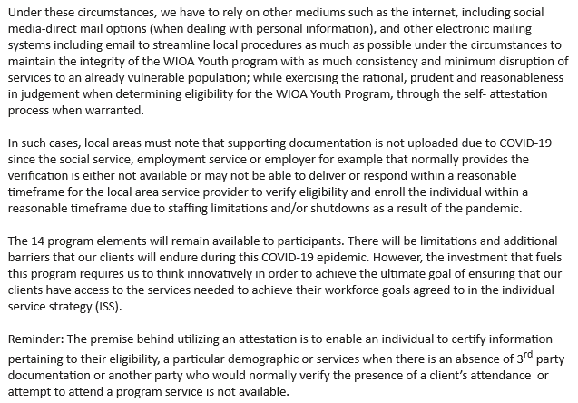
- Youth Demographic Snapshot and ISS
  - In addition to action items listed above to validate youth Eligibility, completing the Demographic Snapshot and ISS will be done in accordance with like items listed for Adult and Dislocated Worker clients above.
No individual in the United States may, on the basis of race, color, religion, sex, national origin, age, disability, or political affiliation or belief, or, for beneficiaries, applicants, and participants only, on the basis of citizenship or participation in any WIOA Title I-financially assisted program or activity, be excluded from participation in, denied the benefits of, subjected to discrimination under, or denied employment in the administration of or in connection with any WIOA Title I-financially assisted program or activity.

