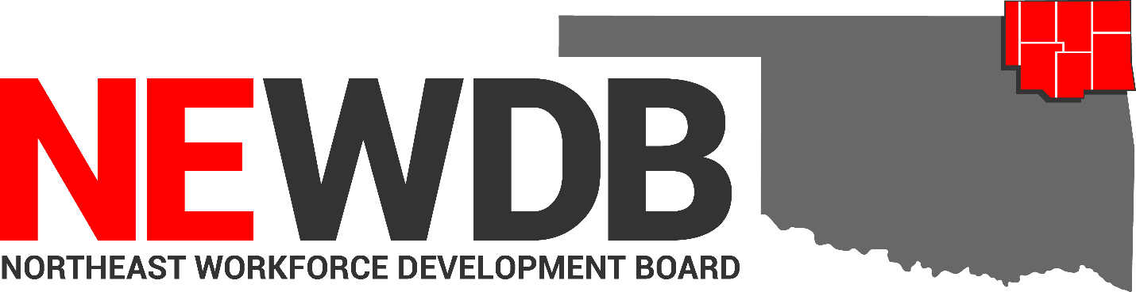

Workforce Innovation and Opportunity Act

Limited English Proficiency Plan

No individual in the United States may, on the basis of race, color, religion, sex, national origin, age, disability, or political affiliation or belief, or, for beneficiaries, applicants, and participants only, on the basis of citizenship or participation in any WIOA Title I-financially assisted program or activity, be excluded from participation in, denied the benefits of, subjected to discrimination under, or denied employment in the administration of or in connection with any WIOA Title I-financially assisted program or activity.

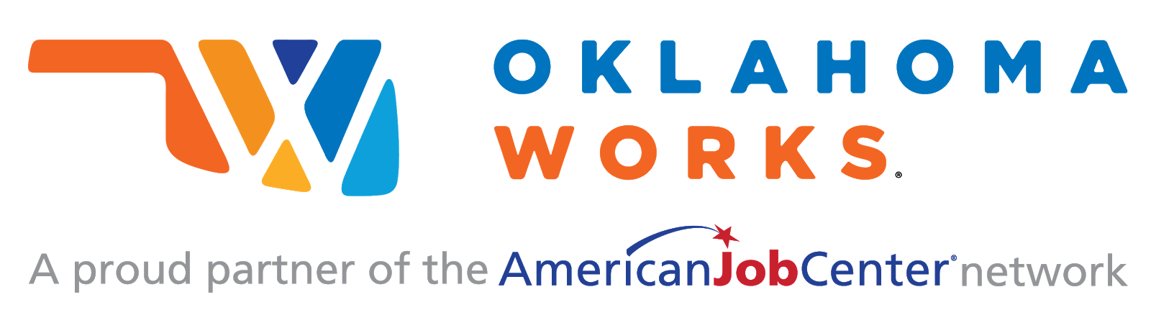

Equal opportunity employment/program.
Auxiliary aids and services are available upon request to individuals with disabilities.
Limited English Proficiency Plan
I. PURPOSE:
The purpose of this policy is to provide guidance and establish the Northeast Workforce Development Board’s (NEWDB) standards, process and procedures regarding the prohibition against national origin discrimination as it affects persons with Limited English Proficiency (LEP). Additionally, this policy serves to provide the Northeast area with a roadmap for establishing and documenting compliance with nondiscrimination obligations and ensuring that LEP individuals receive the necessary assistance to participate in the programs and activities of the Local Area. This policy is established in accordance with the Workforce Innovation and Opportunities Act (WIOA), the Oklahoma Office of Workforce Development (OOWD), and any other applicable State and Federal laws, rules and regulations.

II. BACKGROUND
The nondiscrimination and equal opportunity provisions found in Section 188 of WIOA and 29 CFR Part 38 prohibit discrimination on the basis of race, color, religion, sex (including pregnancy, childbirth, and related medical conditions, transgender status, and gender identity), national origin (including LEP), age, disability, or political affiliation or belief, or, for beneficiaries, applicants, and participants only, on the basis of citizenship status or participation in a WIOA Title I-financially assisted program or activity.
National origin discrimination now includes LEP under 29 CFR Section 38.9 and specifically states that in providing any aid, benefit, service, or training under a WIOA title I-financially assisted program or activity, a recipient must not, directly or through contractual, licensing, or other arrangements, discriminate on the basis of national origin, including LEP. Additionally, 29 CFR Section 38.41 added “LEP and preferred language” to the list of categories of information that each recipient must record about each applicant, registrant, eligible applicant/registrant, participant, and terminee.

III. REFERENCES:
- The Workforce Innovation and Opportunity Act (WIOA) (29 USC § 3248)
- Title 29 Code of Federal Regulations (CFR) Part 38
- Department of Labor (DOL) Training and Employment Notice (TEN) 28-16, Subject: Best Practices, Partnership Models, and Resources Available for Serving English Language Learners, Immigrants, Refugees, and New Americans (January 9, 2017)
- OWDI #17-2017

BABEL NOTICE: (29CFR 38.9(g)(3)): This document contains vital service information. If English is not your preferred language, please contact:

Northeast Workforce Development Board
Jeremy Frutchey, EO Officer
1503 N Lynn Riggs Blvd, Ste. D
Claremore, OK 74017
Phone: 918.907.0902 or Cell: 405.269.2821
Email: jeremy.frutchey@northeastworkforceboard.com

or,

State Equal Opportunity Officer
Oklahoma Office of Workforce Development
Ferris Barger
900 N Portland Avenue, BT 300
Oklahoma City, OK 73107
Office: 405.208.2519
Email: ferris.barger@okcommerce.gov

To enable telephone conversation between people with speech or hearing loss and people without speech or hearing loss please call Oklahoma Relay at 711 (http://www.oklahomarelay.com/711.html) or TDD/TTY: 800-722-0353.

IV. DEFINITIONS:
- Babel Notice: a short notice included in a document or electronic medium (e.g. web site, application, ‘‘app’’ email) in multiple languages informing the reader that the communication contains vital information and explaining how to access language services to have the contents of the communication provided in other languages (29 CFR Section 38.4(i)).
- Employment-related training: training that allows or enables an individual to obtain skills, abilities and/or knowledge that are designed to lead to employment (29 CFR Section 38.4(t)).
- Limited English Proficiency (LEP) individual: an individual whose primary language for communication is not English and who has a limited ability to read, speak, write, and/or understand English. An LEP individual may be competent in English for certain types of communication (e.g., speaking or understanding), but still be LEP for other purposes (e.g., reading or writing) (29 CFR Section 38.4(hh)).
- Limited English Proficiency (LEP) Plan: A written language access plan which assists in ensuring that LEP individuals have meaningful access to WIOA Title I-financially assisted programs and activities (29 CFR Section 38.9 Appendix).
- Meaningful Access: Language assistance that results in accurate, timely, and effective communication at no cost to the LEP individual. For LEP individuals, meaningful access denotes access that is not significantly restricted, delayed, or inferior as compared to programs or activities provided to English proficient individuals.
- Primary language: An individual’s primary language is the language in which an individual most effectively communicates, as identified by the individual.
- Vital Documents: Forms or documents designed and utilized by the NEWDB that are critical for accessing federally funded services or benefits or are required by law. Vital documents can include but are not limited to applications for WIOA programs, consent or programmatic forms that inform or require participant signature of consent, or letters designed by the NEWDB requesting eligibility documentation.

V. NEWDB LEP POLICY AND PLAN
- PROCESS: Reasonable Steps to Ensure Meaningful Access for LEP Individuals
As a recipient of federal Title 1 funds, the NEWDB, One Stop Operator and contracted Service Provider have the responsibility to take reasonable steps to ensure non-discrimination and meaningful access to services in service of LEP individuals, Under (29 CFR Section 38.9(b)(1)) such steps must include, but are not limited to, the following:

- Conducting an assessment of an LEP individual to determine their language assistance needs, as documented in the Adult, Dislocated Worker and Youth eligibility forms (see OOWD Data Validation at:
https://oklahomaworks.gov/wp-content/uploads/2019/05/OWDI-02-2019_Data-Validation_Combined.pdf).
- Providing oral interpretation or written translation of both hard-copy and electronic materials, in the appropriate non-English languages, to LEP individuals.
- Conducting outreach to LEP communities to improve service delivery in needed languages.

The NEWDB requires that every program delivery method, whether it be in person, electronic, or by phone, conveys in the appropriate language how an LEP individual may effectively learn about, participate in, and/or access any aid, benefit, service, or training available to them. As new methods for the delivery of information or assistance are developed, the NEWDB is will take reasonable steps to ensure that LEP individuals remain able to learn about, participate in, and/or access any aid, benefit, service, or training available to them (29 CFR Section 38.9(c)).

- Language Assistance Services
Language assistance generally comes in two forms: oral interpretation or written translation. The NEWDB and Title I grant recipients will ensure that above all, these services are free of charge and provided in a timely manner. An LEP individual must be given adequate notice about the existence of interpretation and translation services and that they are available free of charge. For LEP individuals who enter an Oklahoma Works American Job Centers, language assistance services must be timely, and with adequate notice, where feasible. Language assistance will be considered timely when it is provided at a place and time that ensures equal access and avoids the delay or denial of any aid, benefit, service, or training (29 CFR Section 38.9(d) and (e)).

- Interpreter Services
The NEWDB shall not require an LEP individual to provide their own interpreter. The NEWDB and Title 1 grant recipients shall not rely on an LEP individual’s minor child or adult family or friend to interpret or facilitate communication, except for the following circumstances:
- In emergency situations while awaiting a qualified interpreter;
- When the information conveyed is of minimal importance to the services to be provided; or;
- When an LEP individual specifically requests that an accompanying adult provide language assistance and they agree to provide assistance to the individual. The NEWDB permits an accompanying adult to serve as an interpreter for an LEP individual. However, there must be a detailed case note documented in the case file of the LEP individual’s decision to use their own interpreter.
When precise, complete, and accurate interpretations or translation of information and/or testimony are critical for adjudicatory or legal reasons, the NEWDB can still provide their own, independent interpreter, even if an LEP individual wants to use their own interpreter as well. This also applies in cases where the competency of the interpreter requested by the LEP individual is not established. (29 CFR Section 38.9(f))

D. Language Services
For languages spoken by a significant portion of the LEP population eligible to be served or likely to be encountered, which may constitute 5% or 1,000 whichever is less of the total area service population, the NEWDB will translate vital information in written materials into these languages.
The NEWDB requires that these translations be readily available upon request in hard copy or electronically. Written training materials offered or used within employment-related training programs are excluded from these translation requirements (see definitions section). However, in all cases, the NEWDB will take reasonable steps to ensure meaningful access for LEP individuals. One applicable option for translation requests is found at: https://www.careeronestop.org/

For languages not spoken by a significant portion of the population eligible to be served or likely to be encountered, the NEWDB will take reasonable steps to meet the particularized language needs of LEP individuals who seek to learn about, participate in, and/or access the aid, benefit, service or training that is available to them. Vital information may be conveyed orally if not translated.

The Babel Notice will be included in all communications of vital information as required in (29 CFR Section 38.9(g) (3) and OWDI 17-2017 and all subsequent state and federal regulations. This includes, but is not limited to, letters or decisions in hardcopy or electronic formats, local policies and eligibility documents.

As required by 29 CFR Part 38, once a recipient becomes aware of the non-English preferred language of an LEP beneficiary, participant, or applicant for aid, benefit, service, or training, the recipient must convey vital information in that language. (29 CFR Section 38.9(h))
E. NEWDB Framework for meaningful access to LEP individuals includes:
- Policy documents, employee manuals, employee training material, posters, web sites, outreach material, contracts, and electronic and information technologies, applications, or adaptations will be made available upon request.
- Language assistance services in the NEWDB area include:
- Interpreter available upon request
- Spanish speaking interpreters are accessible for every office
- Referral for ELP/ELL assessment and/or skills training courses
- Online translating software
- Rapid response is available in Spanish upon request
- Marquees provide slides in Spanish
- OkJobMatch can be translated into approximately 106 different languages by simply selecting the language you wish at the bottom of the home page.
- The NEWDB One-Stop Operator (OSO) will provide training for workforce system staff and will have oversight for the implementation of the LEP plan. The Operator will provide workforce system staff with guidance regarding the implementation of the LEP Plan and serve as a resource during the implementation phase.
- The NEWDB ensures quality control, including monitoring, a complaint process, addressing complaints, and obtaining feedback from stakeholders and employees. These requirements of the LEP Plan are covered in the NEWDB Grievance policy and monitoring is included in the NEWDB Monitoring Schedule.
- The NEWDB requires the Title I providers to document provision of language services through self-attestation, detailed program notes and the Individual Employment Plan (IEP)/Individual Service Strategy (ISS).
- The LEP plan will be revisited bi-annually to reflect changes in any of the following:
- New recommendations and government guidance
- Changes in the Local Area’s operations as well as the experiences and lessons learned.
- Changing demographics.
- Stakeholder and beneficiary feedback
Note: The LEP plan is not a fixed document and may require modifications as needed to reflect the Northeast Workforce Development Area (NEWDA) specific program and service needs.

VI. EQUAL OPPORTUNITY AND NONDISCRIMINATION STATEMENT: All Recipients, and Sub recipients/Sub grantees must comply with WIOA’s Equal Opportunity and Nondiscrimination provisions which prohibit discrimination on the basis of race, color, religion, sex (including pregnancy, childbirth, and related medical conditions, transgender status, and gender identity), national origin (including limited English proficiency), age, disability, political affiliation or belief, or, for beneficiaries, applicants, and participants only, on the basis of citizenship status or participation in a WIOA Title-I financially assisted program or activity.

VII. POLICY ADDITIONS AND CLARIFICATIONS:
The NEWDB Executive Director is authorized to issue additional instructions, guidance, approvals, forms, etc. to further implement the requirements of this policy.

Approved by NEWDB February 12, 2020

