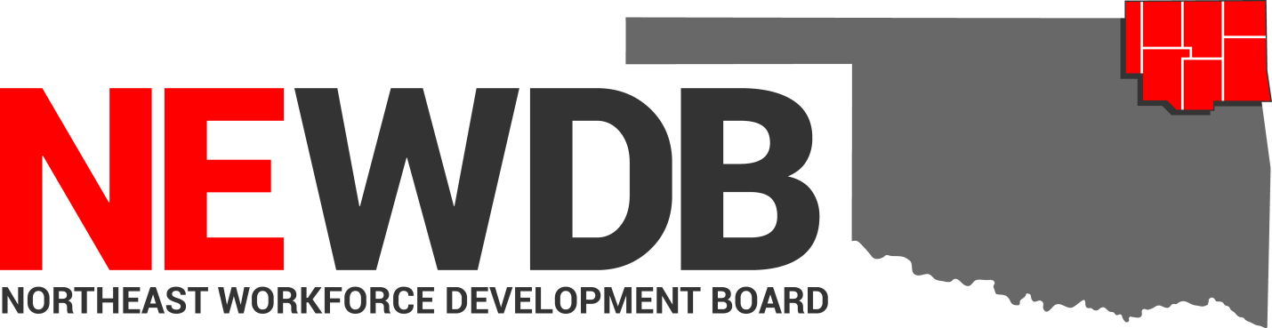

Workforce Innovation and Opportunity Act

Inclement Weather and
Office Closing Policy

No individual in the United States may, on the basis of race, color, religion, sex, national origin, age, disability, or political affiliation or belief, or, for beneficiaries, applicants, and participants only, on the basis of citizenship or participation in any WIOA Title I-financially assisted program or activity, be excluded from participation in, denied the benefits of, subjected to discrimination under, or denied employment in the administration of or in connection with any WIOA Title I-financially assisted program or activity.

Equal opportunity employment/program.
Auxiliary aids and services are available upon request to individuals with disabilities.

I. Purpose
This policy establishes an inclement weather process for the Northeast Development Workforce Board and the American Job Centers that are located within the seven-county area that it serves.

II. Background
The safety of employees and partners is a priority for the Northeast Development Workforce Board. At times, emergencies such as severe weather, fires, power failures, etc. can disrupt office operations. In extreme situations these emergencies may require closing of an American Job Center. In collaboration with partner agencies, the NEWDB will make the determination and notify employees and partners affected by the closing. The NEWDB will utilize the closing of other State offices as a gauge to determine if it is necessary to close an American Job Center. The NEWDB will remain closed for the briefest period of time possible.
III. Local Policy
- Office Closing Procedure:

Office Closure Procedure before normal office hours begin.
- The One Stop Operator will gather the following information:
- Gather current weather conditions in the specific community.
- Check current road conditions on ODOT website.
- Projections of rapid deterioration of road conditions during operating hours.
- Other weather-related closing and / or early dismissals (particularly state and local agencies).
- Once all of this information is gathered the One Stop Operation will contact NEWDB Executive Director and OESC Area Manager and a decision will be made.
- Once a decision is made to close a center or delay opening, the OESC Area Manager will call the Center Manager for the particular center in question. The goal will be to make the decision by 7 AM. The impacted Center Manager will then be responsible to call employees of their agency. The Operations Manager will be notified of the decision and will be responsible for contacting service provider staff. If a system partner is co-located in the center, the One Stop Operator will notify the co-located partners.
- The One Stop Operator will also notify the appropriate local media to announce the closing or late arrival.
Office Closure Procedure during normal office hours
- One Stop Operator will gather the following information:
- Gather Current weather conditions in the specific community.
- Check current road conditions on ODOT website.
- Projections of rapid deterioration of road conditions during operating hours.
- Other weather-related closing and / or early dismissals (particularly state and local agencies).
- Once all of this information is gathered the One Stop Operation will contact NEWDB Executive Director and OESC Area Manager and a decision will be made.
- Once a decision is made to close a center, the OESC Area Manager will call the Center Manager for the particular center in question. The impacted Center Manager will then be responsible to call employees of their agency. The Operations Manager will be notified of the decision and will be responsible for contacting service provider staff. If a system partner is co-located in the center, the One Stop Operator will notify the co-located partners.
- The One Stop Operator will also notify the appropriate local media to announce the early dismissal.

- Compensation
- Each agency will refer to their specific policies for compensation guidelines.
BABEL NOTICE: (29CFR 38.9(g)(3)): This document contains vital service information. If English is not your preferred language, please contact:

Northeast Workforce Development Board
Jeremy Frutchey, EO Officer
1503 N Lynn Riggs Blvd, Ste. D
Claremore, OK 74017
Office: 918.907.0902 or Cell: 405.269.2821
Email: jeremy.frutchey@northeastworkforceboard.com

or,

State Equal Opportunity Officer
Oklahoma Office of Workforce Development
Ferris Barger
900 N Portland Avenue, BT 300
Oklahoma City, OK 73107
Office: 405.208.2519
Email: ferris.barger@okcommerce.gov

To enable telephone conversation between people with speech or hearing loss and people without speech or hearing loss please call Oklahoma Relay at 711 (http://www.oklahomarelay.com/711.html) or TDD/TTY: 800-722-0353.

IV.EQUAL OPPORTUNITY AND NONDISCRIMINATION STATEMENT: All Recipients, and Sub recipients/Sub grantees must comply with WIOA’s Equal Opportunity and Nondiscrimination provisions which prohibit discrimination on the basis of race, color, religion, sex (including pregnancy, childbirth, and related medical conditions, transgender status, and gender identity), national origin (including limited English proficiency), age, disability, political affiliation or belief, or, for beneficiaries, applicants, and participants only, on the basis of citizenship status or participation in a WIOA Title-I financially assisted program or activity.
V. POLICY ADDITIONS AND CLARIFICATIONS:
The NEWDB Executive Director is authorized to issue additional instructions, guidance, approvals, forms, etc. to further implement the requirements of this policy.

Approved by NEWDB 11.6.2019

