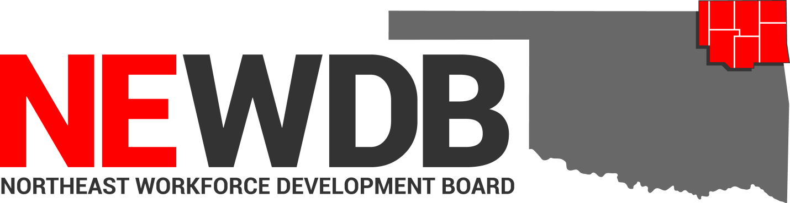

Workforce Innovation and Opportunity Act

Assessment and Individual Service Strategy (ISS) Policy

No individual in the United States may, on the basis of race, color, religion, sex, national origin, age, disability, or political affiliation or belief, or, for beneficiaries, applicants, and participants only, on the basis of citizenship or participation in any WIOA Title I-financially assisted program or activity, be excluded from participation in, denied the benefits of, subjected to discrimination under, or denied employment in the administration of or in connection with any WIOA Title I-financially assisted program or activity.
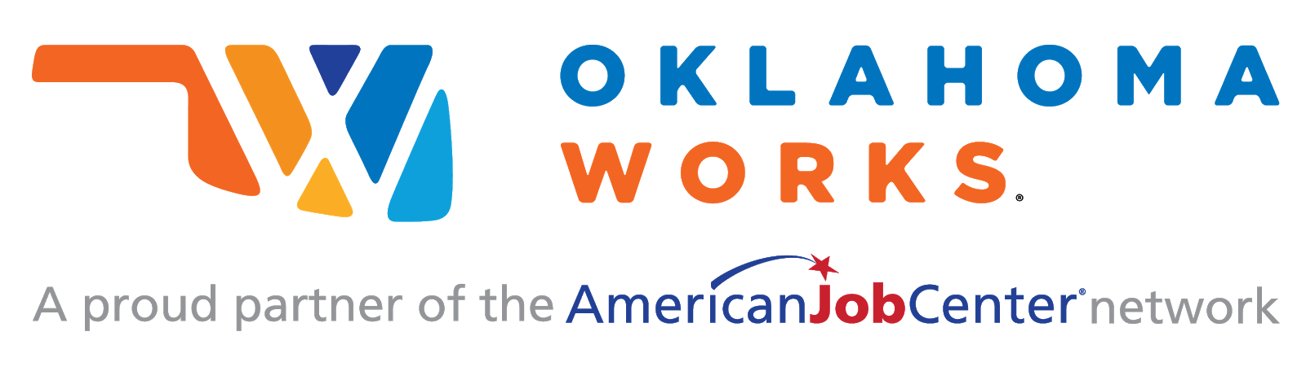

Equal opportunity employment/program.
Auxiliary aids and services are available upon request to individuals with disabilities.

Assessment & ISS Policy
I.PURPOSE:
The purpose of this policy is to provide guidance to the Northeast Workforce Development Area (NEWDA) system partners in the objective assessment process and in the development of the Individual Service Strategy (ISS) for individuals who have been determined eligible for career services provided through the Youth activities of the Workforce Innovation and Opportunity Act (WIOA). This policy is established in accordance with applicable State and Federal laws and regulations.

II.BACKGROUND:
The Oklahoma Office of Workforce Development (OOWD), as the Governor’s chosen Workforce Innovation and Opportunity Act (WIOA) administrative entity, provides guidance on the assessment practices that are to be utilized by the Oklahoma Works one-stop centers in the assessments of WIOA participants and to communicate Oklahoma’s processes and procedures for the development of an Individualized Service Strategy (ISS) for each individual determined to be eligible for Title I Youth programs. OOWD policy establishes the minimum standards for procedures to be developed and adopted by each local workforce development area.

The goal of WIOA is to align services, establish consistency with WIOA partners and to promote program collaboration with in the Oklahoma Works system creating greater efficiency in utilizing existing assessment processes while decreasing duplication of services within the WIOA partner system.

III.REFERENCES:
- The Workforce Innovation and Opportunity Act (WIOA)
- U.S. Department of Labor Employment and Training Administration (DOLETA)
- TEGL No. 10-16, Change 1
- TEGL No. 21-16
- Federal Register / Vol. 83, N. 24/Monday, February 5, 2018/Notices; Tests Determined to Be Suitable for Use in the National Reporting System for Adult Education
- National Reporting System for Adult Education: State Assessment Policy Guidelines, Revised August 9, 2018
- WIOA sec. 134(c)(2)(A)(xii)(II)
- 20 CFR § 680.170
- OWDI 02-2016, Change 2
- OWDI 04-2019

BABEL NOTICE: (29CFR 38.9(g)(3)): This document contains vital service information. If English is not your preferred language, please contact:

Northeast Workforce Development Board
Jeremy Frutchey, EO Officer
1503 N Lynn Riggs Blvd, Ste. D
Claremore, OK 74017
Phone: 918.907.0902 or Cell: 405.269.2821
Email: Jeremy.frutchey@northeastworkforceboard.com
or,

State Equal Opportunity Officer
Oklahoma Office of Workforce Development
Ferris Barger
900 N Portland Avenue, BT 300
Oklahoma City, OK 73107
Office: 405.208.2519
Email: Ferris.barger@okcommerce.gov

To enable telephone conversation between people with speech or hearing loss and people without speech or hearing loss please call Oklahoma Relay at 711 (http://www.oklahomarelay.com/711.html) or TDD/TTY: 800-722-0353. normal

IV. INDIVIDUAL SERVICE STRATEGY:
The Individual Service Strategy (ISS) is an assessment for WIOA Title I Youth participants, to determine skills, interests, needs, and personal goals. The ISS is done in collaboration with the Youth participant and the Title I case manager to expand the youth’s connections, understanding and coordination of services around the 14 youth elements required by WIOA. The ISS is an ongoing strategy that is flexible when necessary to accommodate the participant’s needs, and is designed to help ensure a positive employment connection, understanding and outcome. Each Youth participant must have an ISS that targets their specific needs. The ISS must identify employment goals, achievement objectives, and the appropriate combination of services needed to achieve the employment goal(s).
Career pathways have been incorporated as part of both the objective assessment and the development of the individual service strategy (ISS). The ISS must be directly linked to one or more of the performance measures.
ISS goals are defined as the desired short and long-term outcomes the participant wants or must achieve to indicate program progression. Achievement objectives are the steps established between the case manager and the client that, when reached, represent successful completion of a particular goal or portion of the ISS.
A. Objective Assessment for Youth.
The ISS starts with an objective assessment. The purpose of the assessment is to assess academic levels, skill levels and service needs of each participant for the purpose of identifying appropriate services and career pathways for youth. The assessment must include a review of the following:

- Basic Skills
- Occupational Skills
- Prior Work Experience
- Employability
- Interests
- Aptitudes
- Supportive service
- Developmental needs

Assessments must also consider a youth’s strengths rather than just focusing on areas that need improvement. A new assessment is not required if it is determined it is appropriate to use a recent assessment conducted pursuant to another education or training program conducted in the last 6 months. Objective assessments must be documented as outlined in Attachment A. The assessment is the basis for the establishment of the Individual Service Strategy (ISS).

B. Developing the ISS
The initial development of an ISS will identify where the participant currently is, where the client wants to be, and the appropriate mix and sequence of services and support to reach a realistic employment goal or career pathway. Updates to the ISS are required when there are changes to the employment goal(s), the training goal, and/or services necessary to remove barriers and achieve the goals listed in the ISS.

The ISS must:
- Be based on the individual needs of the youth participant;
- Be directly linked to one or more indicators of performance described below:
- Employment Rate – 2nd Quarter After Exit;
- Employment Rate – 4th Quarter After Exit;
- Median Earnings – 2nd Quarter After Exit;
- Credential Attainment;
- Measurable Skill Gains; and
- Effectiveness in Serving Employers.
- Identify career pathways that include education and employment goals;
- Consider career planning and the results of the objective assessment;
- Prescribe achievement objectives and services for the participant.

OKJobMatch (OJM) is the tool used to record the ISS. Each youth participant’s plan is entered by choosing “Individual Service Strategy” in the Enrollment Details section of the Youth program. Please note that guidance pertaining to the development of the ISS, required for each Title I Youth participant, is found in current WIOA Title I Youth Program Guidance, OWDI #02-2016, Change 2.

The virtual ISS includes the fourteen (14) components below, and are further described in Attachment A to this issuance.
- Objective Assessment & Career Research.
- Employment Goals & Achievement Objectives.
- Training Goals.
- Client Strengths and Attributes.
- Combination of Services to Overcome Needs/Barriers.
- Assistive Technology Needs for Achieving Goals
- Client Responsibilities and Agency Responsibilities.
- Economic Need Statement and Planning.
- Supportive Service Needs.
- Follow-up Services Planned.
- Performance Goals & Accountability Indicators.
- Client Progress Review.
- Additional Notes.
- Client Involvement Statement.

The initial development of the ISS requires entries in OJM for components 1 - 11 and component 13. However, the initial entry for Supportive Service Needs (component 9) may, for example, be a statement that the participant has indicated they currently have no supportive service needs and the topic will be reviewed during future contacts. Additionally, an entry of not applicable (N/A) may be entered in a section that does not pertain to the individual. For example, N/A may be entered when there are no Assistive Technology Needs (component 10), or when Additional Notes (component 13) are not vital to the initial ISS.
The development of ISS covers all 14 components and requires entries in OJM.
In the development of the ISS, the NEWDB requires the use of the Youth Services Individual Service Strategy Template, Attachment C. The template is intended to aid the case manager and youth participant in the development of the ISS. The template does not replace the ISS documentation required in OJM. As part of the progress review, the template must be reviewed at least every 30 days or as significant changes occur that have an impact on participant progress. Significant changes include, but are not limited to: change in career pathway employment or training goal, or life event that may alter or impede participant progress. The ISS Template must be uploaded in OKJobMatch as part of the ISS development documentation.

C. Client Progress Review
Progress reviews of the ISS goals must be documented in component 12 of the ISS, Client Progress Review. Progress reviews of the ISS must be conducted at least every thirty days for active participants and once a quarter for individuals in follow-up. Contact for reviews may be made by phone, text messaging, mail, email, office or on-site visits or other available media. The review must be documented in a detailed program note and updated in the virtual ISS section of OJM.

Reviews will focus on progress in the training program, progress towards the employment goal, supportive service needs and any personal needs related to the achievement of the employment goal. The Career Manager should enter the date the review was conducted in the event the note is not entered into OJM on the date the actual periodic review was conducted, as the system will automatically refer to the date that the note is entered. The note must be entered into the system no less than 48 hours after the review, with the exception of weekends, holidays, closures, sick days, or other unforeseeable event that would prevent a note entry within 48 hours.

If the Career Manager is unable to reach the participant for routine progress review updates or the participant does not follow up, the Career Manager must document each contact attempt/lack of follow up in a program note. The Career Manager must exhaust all sources of contact, including alternate contacts, as part of the progress review process.

The ISS must be amended when necessary to reflect any deviations from the initial employment plan or service strategy.

D. The Client Involvement Statement.
The final component of the ISS is a signed Client Involvement Statement. The participant must agree to the employment goal(s), achievement objectives, and combination of services listed in their ISS, and virtually sign the Client Involvement Statement upon development.
Changes to the ISS do not require a new virtual signature unless there is a change in the training or employment goals, achievement objectives, or the combination of services to be provided. Case Management updates do not require a new client involvement statement.

Information found in the ISS, does not have to be duplicated in Program Notes, unless required by current Data Validation policy.

V. TYPES OF ASSESSMENTS (Title I Youth)
- Objective Assessment
An objective assessment is pre-enrollment activity required to be provided to each Title I youth per section 129 (c)(1)(A) of WIOA. The assessment must include a review of the youth’s academic levels, skill levels, and service needs of the individual, which includes a review of basic skills, occupational skills, prior work experience, employability, interests, aptitudes, supportive service needs, and developmental needs. The assessment must also consider the youth’s strengths, motivations, assets, and unique personality rather than just focusing on areas that need improvement. The purpose of the objective assessment is to identifying appropriate services and career pathways that are supported by the assessment and appropriate for the individual youth participant and all information must be incorporated into the youth’s individual service strategy (ISS).

NEWDB utilizes basic skills assessment instruments that are valid and appropriate for the target population, providing reasonable accommodation in the assessment process, if necessary, for individuals with disabilities. Any formalized testing used must be appropriate, fair, cost effective, well-matched to the test administrator’s qualifications, and be easy to administer and interpret results. Skills related gains may be determined through less formal alternative assessment techniques such as observation, interviews, and evaluations. Previous basic skills assessments that have been conducted within the past six months may be used if available. This may include assessments completed by a secondary school, Vocational Rehabilitation, Adult Basic and Literacy Education, or other education or training providers.

Note: For purposes of the basic skills assessment portion of the objective assessment, programs are not required to use assessments approved for use in the Department of Education’s National Reporting System (NRS), nor are they required to determine an individual’s grade level equivalent or educational functional level (EFL), although use of these tools is permitted.

1. Assessments utilized by the Service Provider must reflect all elements included in this policy. A sample of assessments utilized may include, but are not limited to the following:
- Career Exploration through the O*Net Interest Profiler via www.mynextmove.org or through OK Career Guide at www.okcareerguide.org . The OK Career Guide assessments are especially helpful for participants who are unsure of their career interests, or who have career interests that do not lead to a self-sufficient wage.
- Participant Budget Form
- Supportive Service Needs Checklist
- Interview

2. Additional assessments which may be utilized as part of the initial or comprehensive assessment, and may also be utilized as remediation exercises as included as part of the IEP may include, but are not limited to the following:

Name Website Subject Area
Quizlet https://quizlet.com/ Math, Science, Language, Arts &
Humanities, Social Science
Math Planet https://www.mathplanet.com/ Pre-Algebra, Algebra 172, Geometry,
SAT, ACT
Homeschool Math https://www.homeschoolmath.net Math K-12

Learn English Online http://www.learn-english-online.org/ ESL, ELL

Perfectly Spoken https://perfectlyspoken.com/ ESL, ELL

3. The WIOA Service Provider is responsible for ensuring appropriate assessments are being conducted internally or appropriate referrals are made to outside providers for such services in accordance with this policy and results are retained as part of the participants service record.

- Educational Functioning Level Gain Assessment
When measuring (EFL) gains after program enrollment under the measurable skill gains indicator, WIOA requires standardized assessment for accountability in documenting client educational gains that are aligned with the NRS educational function levels. EFL gains are key indicators of programs’ performance and success in preparing WIOA participants for training, postsecondary education opportunities, gainful employment and economic self-sufficiency. EFL measures are defined by the participant’s ability to perform literacy-related tasks in the specific skill areas of reading, math and speaking. The NRS educational function level of a student is measured by scale scores on NRS approved standardized assessments.

A process which allows for comparability across programs within the state in order to provide fair and equitable access to services for adult learners, collect consistent data regarding learner placement and advancement, and maintain accurate data for program planning, improvement, and accountability is required. Consistency across WIOA funded programs in the state is crucial for determining the instructional needs of individual learners, determining the effectiveness of instruction through learner gains, and providing information regarding NEWDB’s program and/or statewide professional development needs.

- Approved assessments for EFL grains as of October 1, 2018:
1) Test of Adult Basic Education (TABE) – Adult Basic Education (ABE) Reading, Language, Mathematics Skills
2) TABE Complete Language Assessment System – English (CLAS-E) – English Language Learners (ELL) Reading, Listening, Writing, and Speaking Skills
3) CASAS – Adult Basic Education Reading and Math; English as a Second Language.
4) Basic English Skills Test (BEST) Literacy 2008 – ELL Reading and Writing Skills
5) BEST Plus 2.0 – ELL Speaking and Listening Skills
To ensure valid results, individuals administering these assessments will follow all assessment administration and scoring guidelines established by the publishers.
- The TABE and CASAS is appropriate for assessing all ABE levels
- TABE CLAS-E, CASAS (Forms 27, 28, 081-088, 513, 514), BEST Plus 2.0, and BEST Literacy are appropriate for assessing ESL levels.
- The TABE Locator and CASAS Appraisal tests should be administered first and then used to determine the appropriate Education Level to administer in each subject area. Adult learners unable to complete the TABE Locator Test will be administered the TABE Literacy Level (L) Test. Level L is not approved to measure learning gain.
- Different Forms of the same Level of the TABE and CASAS will be used for the pre- and post-assessments. Example: If a student is pre-assessed using TABE Form 11, Level M, they would then be post-assessed using TABE Form 12, Level M.
- TABE 9/10 should never be mixed with TABE 11/12. Students tested in TABE 9 should be assessed TABE 10. TABE 11 should be paired with TABE 12 only.
- A student’s lowest scale score will be used for placement in an EFL and to document learning gains in accordance with NRS guidelines. If this is not the case, written documentation should be placed in the student file explaining why the lowest scale score subject area is not being tracked for learning gain. Subject area scores to be used for measuring learner gain include reading, total math, or language are located in attachment A.

- Pre-Assessment: A pre-assessment should assess the learner in the area that are the focus of instruction, using an appropriate standardized test. Pre-assessment should be conducted within two weeks (10 business days) of enrollment. Pre-assessment scores must be documented in the State-mandated information system, OKJobMatch (OJM) once the assessment is provided and the measurable skills gain is entered into the system. Documentation must be noted in the participants IEP/ISS and documentation must be uploaded in the applicable enrollment upload.
- Post-Assessment: If a participant is pre-assessed for the measurable skills gain EFL performance measure the participant must receive the appropriate instructional hours before the participant may be post-assessed according to the following NRS-approved publisher guidelines:

- TABE 9/10 – Entry Levels 1-4: Minimum 40 hours of instruction (50-60 recommended)
- TABE 9/10 – Entry Levels 5-6: Minimum 30 hours of instruction (30-59 recommended)
- TABE 11/12 – Entry Levels 1-6: Minimum 40 hours of instruction (50-60 recommended)
- CASAS – Levels A – D: Minimum 40 hours of instruction (70-100 recommended)
- TABE – CLAS-E: Minimum 50 hours of instruction (60-95 recommended)
- BEST Plus 2.0 Minimum 60 hours of instruction (80-100 recommended)
- BEST Literacy Minimum 60 hours of instruction (80-100 recommended)

Based on the test publisher recommendations and to avoid a possible “practice effect,” the same TABE Form (11 or 12) should not be administered to a participant more often than every six months or 120 instructional hours.

If a participant exits the program without taking a post-assessment, a new assessment should be administered to determine EFL and no EFL may be obtained without the minimum hours of instruction requirement.
Post-assessment scores can only be documented in OJM once the required number of instruction hours have been completed and documented. Documentation must be noted in the participants ISS and documentation must be uploaded in the applicable enrollment upload.

- Documentation for Performance Accountability and Reporting:
- Service Entry:
Services should be entered into the applicable enrollment at the time the service is provided, and no later than seven calendar days after service delivery. The service date must always reflect the actual date of service. Only the actual service delivered to the participant should be entered into the system.

A service must be entered that supports the required instructional hours according to guidance provided and must be supported by uploaded documentation. The service must have the section “leading to a credential” marked “YES” in order for the participant to fall within the denominator of the MSG performance indicator.

- Measurable Skills Gains:
The Educational Functioning Level - Measurable skills gain is documented by at least one educational function level gain of a participant who is receiving instruction below the postsecondary level. This gain may be achieved by comparing the participants’ initial EFL, as measured by a pre-assessment, with the participants’ EFL, as measured by a post-assessment. (See V. B of this policy)

In order for a participant to fall within the denominator there are three items that are determining factors: 1) they must be either designated in the applicable enrollment demographics as an English Language Learner or Basic Skills Deficient/Low levels of Literacy. 2) School status is determined by the education status, highest grade completed, and highest credential or postsecondary level at program enrollment. 3) A participant must have at least one service entered in the applicable enrollment service and training plan that is designated as a service that leads to a credential.

In order for a participant to fall within the numerator there are three items that are determining factors: 1) there must be a MSG-EFL entered into the MSG section in OJM and it must be attained within the reporting period 2) pre- and post-assessment scores must be entered into the applicable enrollment testing section of OJM. 3) Documentation must be uploaded into OJM, documenting the assessments, and the required instruction hours based upon guidance.

- Monitoring & Quality Assurance:
The NEWDB is responsible for ensuring that policies within the NEWDA are followed, expectations are being met, and compliance with WIOA requirements, including monitoring of the NE One-Stop Operator, Northeast’s Fiscal Agent, and the NE Program Service Provider.
The NEWDB acknowledges that the Oklahoma Office of Workforce Development (OOWD) and the U.S. Department of Labor and the U.S. Department of Education have the authority to monitor and assess activities to ensure that Federal awards are used for authorized purposes in compliance with Final Rules, federal regulations, and State policies, and that those laws and regulations are enforced properly, including but not limited to 20 CFR 683.400(c)(1), 683.410(b)(2), and 29 CFR 38.51. State and Federal maintain oversight of recipient and sub-recipient compliance, including the NEWDB, the NE One-Stop Operator, Northeast’s Fiscal Agent, and the NE Program Service Provider. OOWD will conduct Program, Fiscal, Equal Opportunity and Nondiscrimination, and Performance/Data Quality on-site and desktop monitoring.
- Record Retention: In accordance with the Code of Federal Regulations, Oklahoma requires Local Areas and WIOA providers to retain records in the participants file and maintain the file for at least three years following the date on which the final cost report charged to a program year’s allotment is submitted, or until all audit and litigation issues are resolved, whichever is later. If any litigation, claim, or audit is started before the expiration of the three-year period, the records then must be retained until all litigation, claims, or audit findings involving the records have been resolved and final action has been taken.
VI. EQUAL OPPORTUNITY AND NONDISCRIMINATION STATEMENT:
All Recipients, and Sub recipients/Sub grantees must comply with WIOA’s Equal Opportunity and Nondiscrimination provisions which prohibit discrimination on the basis of race, color, religion, sex (including pregnancy, childbirth, and related medical conditions, transgender status, and gender identity), national origin (including limited English proficiency), age, disability, political affiliation or belief, or, for beneficiaries, applicants, and participants only, on the basis of citizenship status or participation in a WIOA Title-I financially assisted program or activity.

VII. POLICY ADDITIONS AND CLARIFICATIONS:
The NEWDB Executive Director is authorized to issue additional instructions, guidance, approvals, forms, etc. to further implement the requirements of this policy.

VIII. ATTACHMENTS
Attachment A: Scale Score Ranges for NRS Educational Functioning Levels
Attachment B: OKJobMatch Virtual IEP/ISS
Attachment C: ISS Template

Approved by NEWDB February 12, 2020

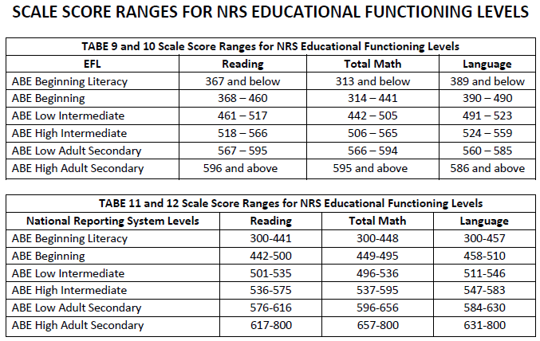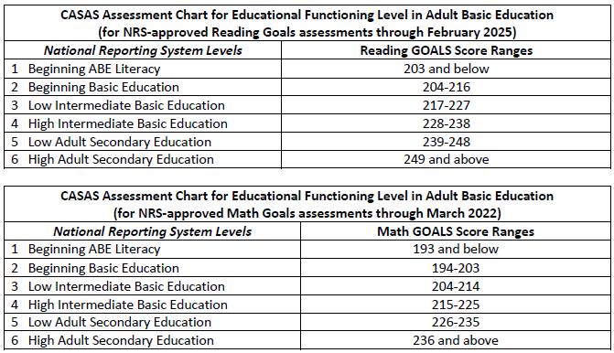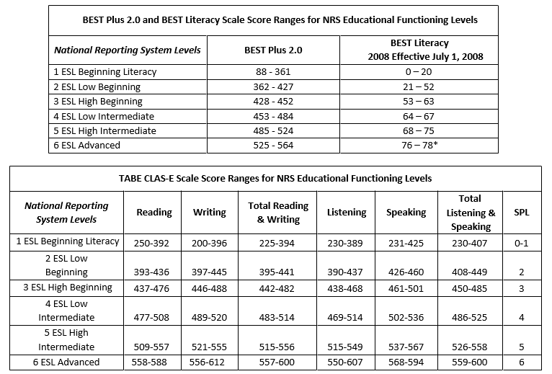
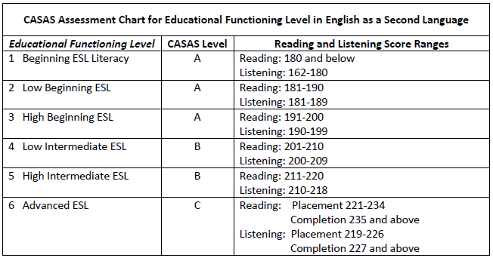

OKJobMatch Virtual IEP/ISS
The following instructions are for the completion of the Individual Service Strategy found in the WIOA Program Enrollment section of OKJobMatch. A summary or narrative of each ISS component must be entered in the virtual ISS, as described in OWDI #03-2019.

 | ISS Components | Instructions
1. | Comprehensive/Objective Assessment & Career Research. | - Identify all comprehensive/objective assessment tools used, including any known assessments given by partner entities.  - List the date or dates assessments were completed.  - Summarize assessment results.  - Provide a brief overview of the participant’s employment history.  - Document any career research completed by/reviewed with the participant.  - Indicate whether participant has a clear understanding of job requirements based on research completed, including labor market information (LMI), when appropriate.  - Address the action taken when results of the career research are not in alignment with assessment results.  - For information regarding the Objective Assessment required for each Youth participant refer to OWDI #02-2016, Change 2.
2. | Employment Goals & Achievement Objectives. | - Identify the employment goal(s) and address alignment with assessment results.  - Identify a timeline for achieving the major employment goal, including achievement objectives leading to the goal.  - If applicable, identify short term and long-term employment goals (e.g., a participant’s career pathway).
3. | Training Goals and Achievement Objectives. |  | - Document that training is necessary to achieve the identified employment goal and/or career pathway goals.  - Identify whether the participant is currently enrolled in training and needs assistance for completion.  - List the type of training, including occupational skills training (OST), on-the-job training (OJT), or other work-based training such as work experience, registered apprenticeship, or a transitional job. Note: The justification for work experience or a transitional job must be entered in section 5.  - Ensure training is for a demand occupation or required for a career pathway that leads to a demand occupation.  - Provide a detailed description of the participant’s training plan, including the training provider, the dates of training, and identification of achievement objectives expected or resulting from the training program attendance.  - Modifications to the training plan must be documented in the ISS as they occur, including:  - Date of modification  - Modification number  - Identification of what is being modified (i.e., record the need and necessary actions to resolve the need).  - Note: A modified training goal must remain aligned with the participant’s career pathway/employment goal and any change to the training plan will require an updated Client Involvement Statement.
4. | Client Strengths and Attributes. |  | - Summarize skills and experiences from prior employment, training, hobbies, volunteer work, and home/family responsibilities as they relate to the employment goal.  - Consider any personal characteristics, assets, and resources that can be related to the employment goal.
5. | Combination of Services to Overcome Needs/Barriers. |  | - Address the appropriate combination of services for the participant to achieve their employment goals. The following barriers must be addressed if identified, and necessary services to overcome all identified barriers must be entered.  - Basic skills deficient;  - School Drop Out;  - Lacks skills, training, or a credential;  - Criminal record;  - English as a Second Language (ESL);  - Lack of transportation;  - Substance Abuse;  - No Driver’s License;  - Lack of Child Care;  - Difficulty finding employment;  - Poor work history, i.e., chronic unemployment or inconsistent work history;  - Homeless; and  - Other identified barriers, as observed, stated by the participant, or listed in the client’s Demographics section of OKJobMatch.  - Include a statement regarding the need for a Transitional Job or Work Experience.  - List any short-term prevocational skills to be provided, such as communications skills, development of learning skills, personal maintenance skills, professional conduct, etc.  - List identified solutions to the needs/barriers listed, including  - Who will provide the service  - Date service is expected to be started and completed  - Document any referrals made to partner agencies and community partners.
6. | Assistive Technology Needs for Achieving Goals. |  | - Address any requested reasonable accommodations without the mention of a disability or details of a disability.  - If applicable, enter a general statement regarding requested assistive technology needs, if any, for seamless customer service delivery.  - Enter N/A if this section does not apply.
7. | Client Responsibilities and Agency Responsibilities. |  | Include responsibilities required by local policy and/or local procedures that are not addressed in the Client Involvement Statement.  Client Responsibility examples:  - Frequency for contacting the designated WIOA case manager;  - Frequency for face-to-face meetings with the WIOA representative;  - Requirement to actively seek and accept training related employment upon completion of services, which may include feedback regarding employment search, e.g., application and resume submission, interviews scheduled or completed, and follow-up with employers;  - Attend training regularly and provide verification of satisfactory training progress, as requested;  - Provision of specific information regarding attained employment before leaving the program, including the name of employer, job title, start date, rate of pay, benefits received or eligible to receive, etc.;  - Respond to all surveys and other requests for information after leaving the program, including the follow-up interview;  - Timely notification of changes in training status, including non-attendance and adding or dropping classes;  - Reporting eligibility for Pell or other grants or financial assistance;  - Reporting address or phone number changes; and  - Other responsibilities, as determined by local policy and procedures.  Responsibilities of WIOA staff may include:  - Oversight/regular monitoring of training activities,  - Submission of appropriate paperwork in a timely manner,  - Providing regular support and assistance as necessary for program success,  - Providing career and job search guidance,  - Ensuring appropriate referrals to workshops and partner entities to enhance the client’s success in the job market, and  - Other responsibilities, as determined by local policy and procedures.
8. | Economic Need Statement and Planning. |  | - Summarize the financial needs articulated by the client through the interview, assessment, and enrollment process.  - For the Adult program, enter the Priority of Service Category.  - Document Pell eligibility/ineligibility, as well as exploration and documentation of other financial aid options such as Tribal funds, scholarships, TAA, education funding for Veterans, etc.  - Note if the participant is in default on student loans and document any steps taken to help the individual get out of default, e.g., the provision of financial literacy information.  - Other information as per local policy and procedures.
9. | Supportive Service Needs. |  | This section pertains specifically to supportive services provided with Title I funds, not partner provided services, which are addressed in section 5.  - Enter the supportive services provided and a brief statement as to the necessity of the service.  - Document the date of provision, amount, etc.;  - Provide an explanation of why any requested supportive services were not provided.
10. | Follow-up Services Planned. |  | For individuals in the Adult and DLW programs:  - Enter details about planned follow-up services after employment attainment.  - Document the services as they occur.
11. | Performance Goals & Accountability Indicators. |  | - List measurable skills gains that are expected according to the training plan.  - List the credentials that are expected outcomes of the training goals/training plan.  - List planned credential attainment dates.
12. | Client Progress Review. |  | - Include a brief summary of how the individual is progressing in the current phase of their employment plan, based on feedback from the participant, an instructor or supervisor, or documents provided such as grades, certificates of completion, etc.  - Indicate the progression made or difficulties encountered during the review period. For example: Training was successfully completed four months ago but Joe has not yet attained employment. A mock interview was set up with ABC, Inc. and it was determined that he does not interview well and also needs resume assistance. A new entry has been entered in section 5, Combination of Services to Overcome Needs/Barriers.  - Any modifications to the ISS resulting from a progress review must be documented in the appropriate section. For example, employment goal, training goals, supportive services, etc.
13. | Additional Notes. |  | Enter any additional information necessary to the ISS and success of the client, such as why there is a gap in service. For example: Joe’s mother passed away and he will travel to New York to attend the services and settle her estate. He has made arrangements with the training provider to resume training in three weeks when he returns to Oklahoma.
14. | Client Involvement Statement. |  | - Virtual attestation to the Client Involvement statement is made in OKJobMatch.  - For modifications to the original IEP not conducted in person with the participant, the case manager must schedule an appointment with the participant as soon as possible to review the IEP and obtain the virtual signature to the Client Involvement Statement.  - For case management only updates, check the box indicating a client agreement is not required.

Information found in the ISS, does not have to be duplicated in Program Notes, unless required by current Data Validation policy.

Youth Individual Service Strategy (ISS)T E M P L A T C E R P A G E
TEMPLATE

ISS Template Instructions

This template is established by the NEWDB and adopted as a best practice from the Employment and Training Administration (ETA) and modified for use within the NEWDA. The template is intended to be used in conjunction with NEWDB policies, organizational culture, data collection systems and service processes.

This template is a required tool intended to aid the case manager in developing a comprehensive ISS. The template is intended to aid the case manager and youth participant in the development of the comprehensive ISS and as part of the progress review process. As part of the progress review, the template must be reviewed at least every 30 days or as significant changes occur that have an impact on participant progress. Significant changes include, but are not limited to: change in career pathway employment or training goal, or life event that may alter or impede participant progress.

The template is not intended to take the place of the Virtual ISS, but serves to document the 14 components of the ISS as prescribed in the NEWDB Youth policy and OKJobMatch Virtual ISS, including:
- Comprehensive Assessment & Career Research.
- Employment Goals & Achievement Objectives.
- Training Goals.
- Client Strengths and Attributes.
- Combination of Services to Overcome Needs/Barriers.
- Assistive Technology Needs for Achieving Goals
- Client Responsibilities and Agency Responsibilities.
- Economic Need Statement and Planning.
- Supportive Service Needs.
- Follow-up Services Planned.
- Performance Goals & Accountability Indicators.
- Client Progress Review.
- Additional Notes.
- Client Involvement Statement.
The ISS Template must be uploaded in OKJobMatch as part of the ISS development documentation.
Components of the ISS
WIOA section 129(c)((1)(B) requires that all eligible youth have an ISS that is directly linked to 1 or more WIOA indicators of performance, identifies career pathways that include education and employment goals, appropriate achievement objectives, and appropriate services for the participant taking into account the assessment. The ISS is planned in conjunction with the youth and adopts a customer and strengths-based customized approach that addresses the unique strengths, challenges and needs of each participant. The ISS should be revisited regularly with the youth.

While there is no one example of the perfect Individual Service Strategy (ISS), strong examples including the following are intended to complement the 14 Youth program elements:

◆ Addresses key goal areas in education, training, employment and personal development
◆ Includes short and long-term goals
◆ Ties the goals to the 14 WIOA Youth program elements/services areas
◆ Includes objectives and action steps
◆ Includes needed referrals for services and support services
◆ Includes timelines with start, end and review dates
◆ Includes appropriate individuals involved
◆ Addresses potential barriers
◆ Includes progress updates/status
◆ Includes youth-staff agreements

Key Features of the Template
◆ The template includes an assessment section. This is not intended to replace the comprehensive assessment that is completed with the youth. Rather it should complement the assessment and provide a quick overview.
◆ The template includes a goals section to identify short- and long-term educational, employment and personal goals.
◆ The template includes all 14 WIOA Youth Program Elements and groups them into four sections.
◆ The template includes an agreement for the youth and staff member to complete. This sets the dynamic of a partnership with equal responsibilities and expectations.

Case Management Tips for Implementing the ISS

Periodic reviews of the form should be conducted to determine if updates or revisions are needed. Below are a few tips for staff to consider as they develop the implementation process:
◆ Dedicate enough time to complete the ISS with the youth. Allow time to brainstorm and develop their “road map” and how they plan on accomplishing their goals.
◆ Introduce the concept of and encourage the youth to develop SMART goals (specific, measurable, achievable, relevant, and time-bound).
◆ Encourage the youth to lead and take ownership of the ISS process.
◆ Develop a schedule for ISS review with the youth.
◆ Celebrate successes and create learning opportunities from setbacks.

Youth Individual Service Strategy (ISS)
for WIOA Youth Services
TEMPLATE FORM
BABEL NOTICE: (29CFR 38.9(g)(3)): This document contains vital service information. If English is not your preferred language, please contact:

Northeast Workforce Development Board or, State Equal Opportunity Officer
Linda Wilson, EO Officer Oklahoma Office of Workforce Development
1503 N Lynn Riggs Blvd, Ste. D Ferris Barger
Claremore, OK 74017 900 N Portland Avenue, BT 300
Office: 918.907.0902 Cell: 406.459.6113 Oklahoma City, OK 73107
Email: linda.wilson@northeastworkforceboard.com Office: 405.208.2519
Email: Ferris.barger@okcommerce.gov
To enable telephone conversation between people with speech or hearing loss and people without speech or hearing loss please call Oklahoma Relay at 711 (http://www.oklahomarelay.com/711.html) or TDD/TTY: 800-722-0353.
Youth Name: |  | Date:
DOB: |  | PID#:
*Do not use social security number for participant I.D.
Framework of an ISS:
1. Directly linked to one or more indicators of performance
- Employment Rate – 2nd Quarter After Exit;
- Employment Rate – 4th Quarter After Exit;
- Median Earnings – 2nd Quarter After Exit;
- Credential Attainment;
- Measurable Skill Gains; and
- Effectiveness in Serving Employers.

2. Based on the objective assessment (list assessments)

3. Identifies a career pathway that includes education and employment goals
Brief Assessment Overview (OJM Virtual ISS-4,5,6,8 & 9)
Identify personal, educational, occupational, financial, medical, childcare, transportation, housing, food/nutrition
Strengths | Challenges (Barriers) | Service/Resource/Partner Agency Referral

Goals (OJM Virtual ISS-2, 3 & 11)
Identify personal, educational, and occupational short- and long-term goals
Goal Type | Short-Term Goal | Long-Term Goal | Performance Indicator(s) Goal is Linked To
Educational Goal

Occupational/Employment Goal

Personal/Social Goal

Program Elements Needed to Achieve Goal
Youth are required to have access to all fourteen WIOA Youth program elements. Please select elements based on needs identified on the participant’s objective assessment.
Improving Educational Achievement | Date Opened | Projected End Date | Actual End Date | Successful Completion
☐ Tutoring: study skills training, and instruction leading to secondary school completion, including dropout prevention strategies  Action Steps/Referrals:  Comments: |  |  |  | ☐ Yes ☐ No  Explain:
☐ Alternative secondary school offerings  Action Steps/Referrals:  Comments: |  |  |  | ☐ Yes ☐ No  Explain:
☐ Activities that help youth prepare for transition to  postsecondary education and training  Action Steps/Referrals:  Comments: |  |  |  | ☐ Yes ☐ No  Explain:
Preparing for and Succeeding in Employment | Date Opened | Projected End Date | Actual End Date | Successful Completion
☐ Paid & unpaid work experience (summer employment, pre-apprenticeship programs, internships, job shadowing, OJT) with Academic & occupational education  Action Steps/Referrals:  Comments: |  |  |  | ☐ Yes ☐ No  Explain:
☐ Labor market & employment information including career awareness, career counseling, and career exploration services  Action Steps/Referrals:  Comments: |  |  |  | ☐ Yes ☐ No  Explain:
☐ Education offered concurrently with workforce preparation and training for a specific occupation  Action Steps/Referrals:  Comments: |  |  |  | ☐ Yes ☐ No  Explain:
Preparing for and Succeeding in Employment | Date Opened | Projected End Date | Actual End Date | Successful Completion
☐ Occupational skills training  Action Steps/Referrals:  Comments: |  |  |  | ☐ Yes ☐ No  Explain:
☐ Entrepreneurial skills training  Action Steps/Referrals:  Comments: |  |  |  | ☐ Yes ☐ No  Explain:
Supporting Youth | Date Opened | Projected End Date | Actual End Date | Successful Completion
☐ Supportive services  Action Steps/Referrals:  Comments: |  |  |  | ☐ Yes ☐ No  Explain:
☐ Adult mentoring  Action Steps/Referrals:  Comments: |  |  |  | ☐ Yes ☐ No  Explain:
☐ Comprehensive guidance & counseling (may include drug & alcohol abuse counseling & referral)  Action Steps/Referrals:  Comments: |  |  |  | ☐ Yes ☐ No  Explain:
☐ Follow-up  Action Steps/Referrals:  Comments: |  |  |  | ☐ Yes ☐ No  Explain:
Developing the Potential of Young People as Citizens & Leaders | Date Opened | Projected End Date | Actual End Date | Successful Completion
☐ Leadership development opportunities/ Opportunities to develop social behaviors, other soft skills, and leadership opportunities  Action Steps/Referrals:  Comments: |  |  |  | ☐ Yes ☐ No  Explain:
Developing the Potential of Young People as Citizens & Leaders | Date Opened | Projected End Date | Actual End Date | Successful Completion
☐ Financial literacy  Action Steps/Referrals:  Comments: |  |  |  | ☐ Yes ☐ No  Explain:
Potential Barriers to Goal Achievement:

Progress Review Updates: Significant Change/Milestone Attainment (Documented in Virtual ISS)
Include any progress, such as but not limited to measurable skill gains, credentials, other goal completions other goal completions, or life events that may impede progress.

Individual Service Strategy Updates & Follow Up (Documented in Virtual ISS)
Date | Virtual ISS Note Update | Youth and Case Manager Initials

ISS for WIOA Youth Services

Youth and Case Manager Agreements: (not included in the Client Involvement Statement)
Include responsibilities required by local policy and/or local procedures that are not addressed in the Client Involvement Statement.
Client Responsibility examples:
- Frequency for contacting the designated WIOA case manager;
- Frequency for face-to-face meetings with the WIOA representative;
- Requirement to actively seek and accept training related employment upon completion of services, which may include feedback regarding employment search, e.g., application and resume submission, interviews scheduled or completed, and follow-up with employers;
- Attend training regularly and provide verification of satisfactory training progress, as requested;
- Provision of specific information regarding attained employment before leaving the program, including the name of employer, job title, start date, rate of pay, benefits received or eligible to receive, etc.;
- Respond to all surveys and other requests for information after leaving the program, including the follow-up interview;
- Timely notification of changes in training status, including non-attendance and adding or dropping classes;
- Reporting eligibility for Pell or other grants or financial assistance;
- Reporting address or phone number changes; and
- Other responsibilities, as determined by local policy and procedures.
Responsibilities of WIOA staff may include:
- Oversight/regular monitoring of training activities,
- Submission of appropriate paperwork in a timely manner,
- Providing regular support and assistance as necessary for program success,
- Providing career and job search guidance,
- Ensuring appropriate referrals to workshops and partner entities to enhance the client’s success in the job market, and
- Other responsibilities, as determined by local policy and procedures.
Youth Signature |  | Case Manager Signature
Date |  | Date

