  - Workforce Innovation and Opportunity Act
Assessment and Individual Employment Plan (IEP) Policy
No individual in the United States may, on the basis of race, color, religion, sex, national origin, age, disability, or political affiliation or belief, or, for beneficiaries, applicants, and participants only, on the basis of citizenship or participation in any WIOA Title I-financially assisted program or activity, be excluded from participation in, denied the benefits of, subjected to discrimination under, or denied employment in the administration of or in connection with any WIOA Title I-financially assisted program or activity

Equal opportunity employment/program. Auxiliary aids and services are available upon request to individuals with disabilities.

Assessment & IEP Policy

I.PURPOSE:
The purpose of this policy is to provide guidance to the Northeast Workforce Development Area (NEWDA) system partners in the comprehensive assessment process and in the development of the Individual Employment Plan (IEP) for individuals who have been determined eligible for intensive and training services provided through the Adult or Dislocated Workers activities of the Workforce Innovation and Opportunity Act (WIOA). This policy is established in accordance with applicable State and Federal laws and regulations.

II.BACKGROUND:
The Oklahoma Office of Workforce Development (OOWD), as the Governor’s chosen Workforce Innovation and Opportunity Act (WIOA) administrative entity, provides this guidance on the assessment practices that are to be utilized by the Oklahoma Works American Job Centers in the assessments of WIOA participants and to communicate Oklahoma’s processes and procedures for the development of an Individualized Employment Plan (IEP) for each individual determined to be eligible for Title I Adult and Dislocated Worker programs. This policy establishes the minimum standards for procedures to be developed and adopted by the Northeast Workforce Development area (NEWDA).
The goal of WIOA is to align services, establish consistency with WIOA partners and to promote program collaboration with in the Oklahoma Works system creating greater efficiency in utilizing existing assessment processes while decreasing duplication of services within the WIOA partner system.

III.REFERENCES:
- The Workforce Innovation and Opportunity Act (WIOA)
- U.S. Department of Labor Employment and Training Administration (DOLETA)
- TEGL No. 10-16, Change 1
- TEGL No. 19-16
- TEGL No. 21-16
- Federal Register / Vol. 83, N. 24/Monday, February 5, 2018/Notices; Tests Determined to Be Suitable for Use in the National Reporting System for Adult Education
- National Reporting System for Adult Education: State Assessment Policy Guidelines, Revised August 9, 2018
- WIOA sec. 134(c)(2)(A)(xii)(II)
- OWDI 19-2017, Change 1
- 20 CFR § 680.170
- OWDI 02-2016, Change 2
- OWDI 04-2019
OWDI 03-2019
BABEL NOTICE: (29CFR 38.9(g)(3)): This document contains vital service information. If English is not your preferred language, please contact:

Northeast Workforce Development Board
Jeremy Frutchey, EO Officer
1503 N Lynn Riggs Blvd, Ste. D
Claremore, OK 74017
Phone: 918.907.0902 or Cell: 405.269.2821
Email: jeremy.frutchey@northeastworkforceboard.com

or,

State Equal Opportunity Officer
Oklahoma Office of Workforce Development
Ferris Barger
900 N Portland Avenue, BT 300
Oklahoma City, OK 73107
Office: 405.208.2519
Email: ferris.barger@okcommerce.gov

To enable telephone conversation between people with speech or hearing loss and people without speech or hearing loss please call Oklahoma Relay at 711 (http://www.oklahomarelay.com/711.html) or TDD/TTY: 800-722-0353.

IV. ASSESSMENT:

A. Initial Assessment
An initial assessment is a basic career service made available to all individuals through the Oklahoma Works American Job Center (AJC) network. The initial assessment includes a basic assessment of skill levels including literacy, numeracy, and English language proficiency, preferred language, as well as aptitudes, abilities (including skills gaps), and supportive service needs in order to determine the level of services needed by the customer.

The use of techniques such as observation, interviews, and evaluations are appropriate initial assessment tools. The selection and use of English Language proficiency assessment tools, and qualified administrators of such tools are to be determined by NEWDA and must be appropriate to the individual receiving the assessment.

The initial assessment should result in a determination of the individual’s next steps, next steps may include but are not limited to:
- a comprehensive assessment and the development of an individual employment plan,
- the provision of training or education services
- appropriate referrals based on the initial assessment
- determination of appropriate program enrollment or co-enrollment
NEWDB utilizes basic skills assessment instruments that are valid and appropriate for the target population, providing reasonable accommodation in the assessment process, if necessary, for individuals with disabilities. Any formalized testing used must be appropriate, fair, cost effective, well-matched to the test administrator’s qualifications, and be easy to administer and interpret results. Skills related gains may be determined through less formal alternative assessment techniques such as observation, interviews, and evaluations.

Previous basic skills assessments that have been conducted within the past six months may be used if available. This may include assessments completed by a secondary school, Vocational Rehabilitation, Adult Basic and Literacy Education, or other education or training providers. When previous assessments do not exist, the WIOA Service Provider must either, conduct an assessment appropriate for the need, or make an appropriate referral to ensure an adequate assessment is conducted and results are made part of the participant’s service record.

Note: For purposes of the basic skills assessment portion of the comprehensive assessment, programs are not required to use assessments approved for use in the Department of Education’s National Reporting System (NRS), nor are they required to determine an individual’s grade level equivalent or educational functional level (EFL), although use of these tools is permitted.

B. Comprehensive Skill and Career Assessment
A comprehensive skill and career assessment are an individualized career service that is provided to an individual after it has been determined that services are required to retain or obtain employment. This assessment will identify the service needs, academic levels, goals, interests, skill levels, abilities, aptitudes, supportive service needs, and measures barriers and strengths of the individual. It includes a review of basic and occupational skills, prior work experience, employability potential, interests, aptitudes, and developmental needs. The purpose of the assessment is to identifying appropriate services and career pathways that are most beneficial for the individual and all information must be incorporated into the Adult or Dislocated Workers individual employment plan (IEP).

1. Assessments utilized by the Service Provider must reflect all elements included in this policy. A sample of assessments utilized may include, but are not limited to the following:
- Career Exploration through the O*Net Interest Profiler via www.mynextmove.org or through OK Career Guide at www.okcareerguide.org . The OK Career Guide assessments are especially helpful for participants who are unsure of their career interests, or who have career interests that do not lead to a self-sufficient wage.
- Participant Budget Form
- Supportive Service Needs Checklist
- Interview

2. Additional assessments which may be utilized as part of the initial or comprehensive assessment, and may also be utilized as remediation exercises as included as part of the IEP may include, but are not limited to the following:

Table 1: Online Assessment Option
Name | Website | Subject Area
Quizlet | https://quizlet.com/ | Math, Science, Language, Arts & Humanities, Social Science
Math Planet | https://www.mathplanet.com/ | Pre-Algebra, Algebra 172, Geometry, SAT, ACT
Homeschool Math | https://www.homeschoolmath.net | Math K-12
Learn English Online | http://www.learn-english-online.org/ | ESL, ELL
Perfectly Spoken | https://perfectlyspoken.com/ | ESL, ELL

For purpose of the basic and occupational skill levels determination, diagnostic testing and other assessment tools may be utilized. Assessment instruments that are utilized must be valid and appropriate for the target population, providing reasonable accommodation in the assessment process, if necessary, for individuals with disabilities.

Any formalized testing used must be appropriate, fair, cost effective, well-matched to the test administrator’s qualifications, and be easy to administer and interpret results. To identify employment barriers and appropriate employment goals the use of in-depth interviewing and evaluations are appropriate assessment tools.

C. Educational Functioning Level Gain Assessment
When measuring (EFL) gains after program enrollment under the measurable skill gains indicator, WIOA requires standardized assessment for accountability in documenting client educational gains that are aligned with the National Reporting System (NRS) educational function levels. EFL gains are key indicators of programs’ performance and success in preparing WIOA participants for training, postsecondary education opportunities, gainful employment and economic self-sufficiency. EFL measures are defined by the participant’s ability to perform literacy-related tasks in the specific skill areas of reading, math and speaking. The NRS educational function level of a student is measured by scale scores on NRS approved standardized assessments.

A process which allows for comparability across programs within the state in order to provide fair and equitable access to services for adult learners, collect consistent data regarding learner placement and advancement, and maintain accurate data for program planning, improvement, and accountability is required. Consistency across WIOA funded programs in the state is crucial for determining the instructional needs of individual learners, determining the effectiveness of instruction through learner gains, and providing information regarding the Northeast program and/or statewide professional development needs.

Effective October 1, 2018, the approved assessments for EFL gains are:
1) Test of Adult Basic Education (TABE) – Adult Basic Education (ABE) Reading, Language, Mathematics Skills
2) TABE Complete Language Assessment System – English (CLAS-E) – English Language Learners (ELL) Reading, Listening, Writing, and Speaking Skills
3) CASAS – Adult Basic Education Reading and Math; English as a Second Language.
4) Basic English Skills Test (BEST) Literacy 2008 – ELL Reading and Writing Skills
5) BEST Plus 2.0 – ELL Speaking and Listening Skills
To ensure valid results, individuals administering these assessments will follow all assessment administration and scoring guidelines established by the publishers.
- The TABE and CASAS is appropriate for assessing all ABE levels
- TABE CLAS-E, CASAS (Forms 27, 28, 081-088, 513, 514), BEST Plus 2.0, and BEST Literacy are appropriate for assessing ESL levels.
- The TABE Locator and CASAS Appraisal tests should be administered first, and used to determine the appropriate Education Level to administer in each subject area. Adult learners unable to complete the TABE Locator Test will be administered the TABE Literacy Level (L) Test. Level L is not approved to measure learning gain.
- Different Forms of the same Level of the TABE and CASAS will be used for the pre- and post-assessments. Example: If a student is pre-assessed using TABE Form 11, Level M, they would then be post-assessed using TABE Form 12, Level M.
- TABE 9/10 should never be mixed with TABE 11/12. Students tested in TABE 9 should be assessed TABE 10. TABE 11 should be paired with TABE 12 only.
- A student’s lowest scale score will be used for placement in an EFL and to document learning gains in accordance with NRS guidelines. If this is not the case, written documentation should be placed in the student file explaining why the lowest scale score subject area is not being tracked for learning gain. Subject area scores to be used for measuring learner gain include reading, total math, or language are located in attachment A.

- Pre-Assessment: A pre-assessment should assess the learner in the area that are the focus of instruction, using an appropriate standardized test. Pre-assessment should be conducted within two weeks (10 business days) of enrollment. Pre-assessment scores must be documented in the State-mandated information system, OKJobMatch (OJM) once the assessment is provided and the measurable skills gain is entered into the system. Documentation must be noted in the participants IEP and documentation must be uploaded in the applicable enrollment upload.
- Post-Assessment: If a participant is pre-assessed for the measurable skills gain EFL performance measure the participant must receive the appropriate instructional hours before the participant may be post-assessed according to the following NRS-approved publisher guidelines:

- TABE 9/10 – Entry Levels 1-4: Minimum 40 hours of instruction (50-60 recommended)
- TABE 9/10 – Entry Levels 5-6: Minimum 30 hours of instruction (30-59 recommended)
- TABE 11/12 – Entry Levels 1-6: Minimum 40 hours of instruction (50-60 recommended)
- CASAS – Levels A – D: Minimum 40 hours of instruction (70-100 recommended)
- TABE – CLAS-E: Minimum 50 hours of instruction (60-95 recommended)
- BEST Plus 2.0 Minimum 60 hours of instruction (80-100 recommended)
- BEST Literacy Minimum 60 hours of instruction (80-100 recommended)

Based on the test publisher recommendations and to avoid a possible “practice effect,” the same TABE Form (11 or 12) should not be administered to a participant more often than every six months or 120 instructional hours.

If a participant exits the program without taking a post-assessment, a new assessment should be administered to determine EFL and no EFL may be obtained without the minimum hours of instruction requirement. Post-assessment scores can only be documented in OJM once the required number of instruction hours have been completed and documented. Documentation must be noted in the participants IEP and documentation must be uploaded in the applicable enrollment upload.

D. Documentation for Performance Accountability and Reporting:
- Service Entry:
Services should be entered into the applicable enrollment at the time the service is provided, and no later than seven calendar days after service delivery. The service date must always reflect the actual date of service. Only the actual service delivered to the participant should be entered into the system.

A service must be entered that supports the required instructional hours according to guidance provided and must be supported by uploaded documentation. The service must have the section “leading to a credential” marked “YES” in order for the participant to fall within the denominator of the MSG performance indicator.

- Measurable Skills Gains:
The Educational Functioning Level - Measurable skills gain is documented by at least one educational function level gain of a participant who is receiving instruction below the postsecondary level. This gain may be achieved by comparing the participants’ initial EFL, as measured by a pre-assessment, with the participants’ EFL, as measured by a post-assessment.

In order for a participant to fall within the denominator there are three items that are determining factors: 1) they must be either designated in the applicable enrollment demographics as an English Language Learner or Basic Skills Deficient/Low levels of Literacy. 2) School status is determined by the education status, highest grade completed, and highest credential or postsecondary level at program enrollment. 3) A participant must have at least one service entered in the applicable enrollment service and training plan that is designated as a service that leads to a credential.

In order for a participant to fall within the numerator there are three items that are determining factors: 1) there must be a MSG-EFL entered into the MSG section in OJM and it must be attained within the reporting period 2) pre- and post-assessment scores must be entered into the applicable enrollment testing section of OJM. 3) Documentation must be uploaded into OJM, documenting the assessments, and the required instruction hours based upon guidance.

V. INDIVIDUAL EMPLOYMENT PLAN
The Individual Employment Plan (IEP) is an individualized career service for Adult and/or Dislocated Workers (DLW) that is jointly developed by the WIOA participant and the Title I case manager.

The IEP is an ongoing strategy that is flexible when necessary to accommodate the participant’s needs, and is designed to help ensure a positive employment connection, understanding and outcome. Each Adult, DLW and Youth must have an IEP that targets their specific needs. The IEP must identify employment goals, achievement objectives, and the appropriate combination of services needed to achieve the employment goal(s).
Career pathways have been incorporated as part of both the assessment and the development of the IEP. The IEP must be directly linked to one or more of the performance measures.

IEP goals are defined as the desired short- and long-term outcomes the participant wants or must achieve to indicate program progression. Achievement objectives are the steps established between the case manager and the client that, when reached, represent successful completion of a particular goal or portion of the IEP.

A. The Comprehensive Assessment
The IEP starts with a comprehensive assessment. The purpose of the assessment is to identify an employment goal or career pathway for the individual, and to determine the skill levels and service needs for the individual to obtain or retain employment. Additional specialized assessments may be required to identify academic levels, goals, interests, skill levels, abilities, aptitudes, and supportive service needs. The comprehensive assessment(s) given and a summary of assessment results must be documented in the participant’s IEP.

A new assessment is not required if it is determined it is appropriate to use a recent assessment conducted pursuant to another education or training program conducted in the last 6 months. Comprehensive assessments must be documented as outlined in Attachment A. The assessment is the basis for the establishment of the IEP.

B. Developing the IEP
The initial development of an IEP will identify where the participant currently is, where the client wants to be, and the appropriate mix and sequence of services and support to reach a realistic employment goal or career pathway. Updates to the IEP are required when there are changes to the employment goal(s), the training goal, and/or services necessary to remove barriers and achieve the goals listed in the IEP.

OJM is the tool used to record the IEP. Each adult or youth participant’s plan is entered by choosing “Individual Employment Plan” in the Enrollment Details section of the appropriate WIOA program (Adult/DLW).

The virtual IEP includes the fourteen (14) components below, and are further described in Attachment A to this issuance.
- Comprehensive Assessment & Career Research.
- Employment Goals & Achievement Objectives.
- Training Goals.
- Client Strengths and Attributes.
- Combination of Services to Overcome Needs/Barriers.
- Assistive Technology Needs for Achieving Goals
- Client Responsibilities and Agency Responsibilities.
- Economic Need Statement and Planning.
- Supportive Service Needs.
- Follow-up Services Planned.
- Performance Goals & Accountability Indicators.
- Client Progress Review.
- Additional Notes.
- Client Involvement Statement.

The initial development of the IEP requires entries in OJM for components 1 - 11 and component 13. However, the initial entry for Supportive Service Needs (component 9) may, for example, be a statement that the participant has indicated they currently have no supportive service needs and the topic will be reviewed during future contacts. Additionally, an entry of not applicable (N/A) may be entered in a section that does not pertain to the individual. For example, N/A may be entered when there are no Assistive Technology Needs (component 10), or when Additional Notes (component 13) are not vital to the initial IEP.

The development of the IEP covers all 14 components and requires entries in OJM.

C. Client Progress Review
Progress reviews of the IEP goals must be documented in component 12 of the IEP, Client Progress Review. Progress reviews of the Individual Employment Plan must be conducted at least every thirty days for active participants and once a quarter for individuals in follow-up. Contact for reviews may be made by phone, text messaging, mail, email, office or on-site visits or other available media. The review must be documented in the Program Notes section of OJM.

Reviews will focus on progress in the training program, progress towards the employment goal, supportive service needs and any personal needs related to the achievement of the employment goal. The Career Manager should enter the date the review was conducted in the event the note is not entered into OJM on the date the actual periodic review was conducted, as the system will automatically refer to the date that the note is entered. The note must be entered into the system no less than 48 hours after the review, with the exception of weekends, holidays, closures, sick days, or other unforeseeable event that would prevent a note entry within 48 hours.

If the Career Manager is unable to reach the participant for routine progress review updates or the participant does not follow up, the Career Manager must document each contact attempt/lack of follow up in a program note. The Career Manager must exhaust all sources of contact, including alternate contacts, as part of the progress review process.

The IEP must be amended when necessary to reflect any deviations from the initial employment

D. The Client Involvement Statement
The final component of the IEP is a signed Client Involvement Statement. The participant must agree to the employment goal(s), achievement objectives, and combination of services listed in their IEP and virtually sign the Client Involvement Statement upon development.
Changes to the IEP do not require a new virtual signature unless there is a change in the training or employment goals, achievement objectives, or the combination of services to be provided. Case Management updates do not require a new client involvement statement.

VII. Monitoring & Quality Assurance:
The NEWDB is responsible for ensuring that policies within the NEWDA are followed, expectations are being met, and compliance with WIOA requirements, including monitoring of the Northeast One-Stop Operator, Northeast’s Fiscal Agent, and the Northeast Program Service Provider.

The NEWDB acknowledges that the Oklahoma Office of Workforce Development (OOWD) and the U.S. Department of Labor and the U.S. Department of Education have the authority to monitor and assess activities to ensure that Federal awards are used for authorized purposes in compliance with Final Rules, federal regulations, and State policies, and that those laws and regulations are enforced properly, including but not limited to 20 CFR 683.400(c)(1), 683.410(b)(2), and 29 CFR 38.51. State and Federal maintain oversight of recipient and sub-recipient compliance, including the NEWDB, the NE One-Stop Operator, Northeast’s Fiscal Agent, and the NE Program Service Provider. OOWD will conduct Program, Fiscal, Equal Opportunity and Nondiscrimination, and Performance/Data Quality on-site and desktop monitoring.

Record Retention: In accordance with the Code of Federal Regulations, Oklahoma requires NEWDB and WIOA providers to retain records in the participants file and maintain the file for at least three years following the date on which the final cost report charged to a program year’s allotment is submitted, or until all audit and litigation issues are resolved, whichever is later. If any litigation, claim, or audit is started before the expiration of the three-year period, the records then must be retained until all litigation, claims, or audit findings involving the records have been resolved and final action has been taken.

VII. EQUAL OPPORTUNITY AND NONDISCRIMINATION STATEMENT:
All Recipients, and Sub recipients/Sub grantees must comply with WIOA’s Equal Opportunity and Nondiscrimination provisions which prohibit discrimination on the basis of race, color, religion, sex (including pregnancy, childbirth, and related medical conditions, transgender status, and gender identity), national origin (including limited English proficiency), age, disability, political affiliation or belief, or, for beneficiaries, applicants, and participants only, on the basis of citizenship status or participation in a WIOA Title-I financially assisted program or activity.

VIII. POLICY ADDITIONS AND CLARIFICATIONS:
The NEWDB Executive Director is authorized to issue additional instructions, guidance, approvals, forms, etc. to further implement the requirements of this policy.

IX. ATTACHMENTS
Attachment A: Scale Score Ranges for NRS Educational Functioning Levels
Attachment B: OKJobMatch Virtual IEP

Approved by NEWDB February 2, 2020

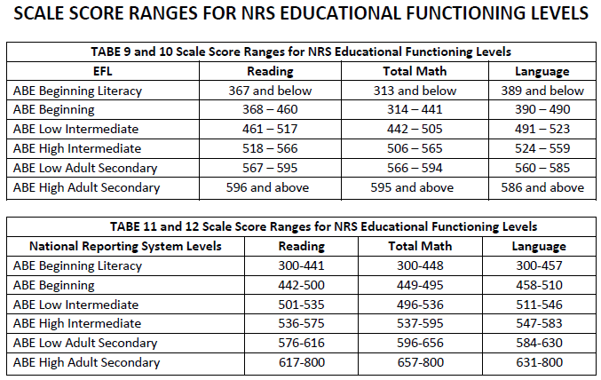
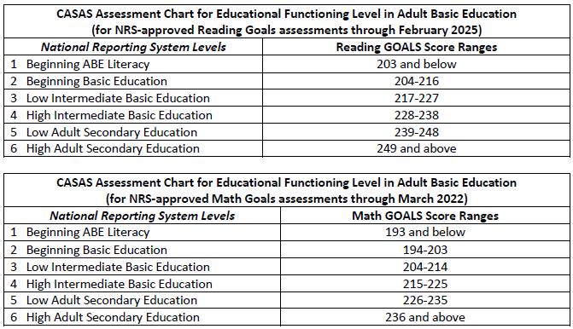

Equal opportunity employment/program. Auxiliary aids and services are available upon request to individuals with disabilities.
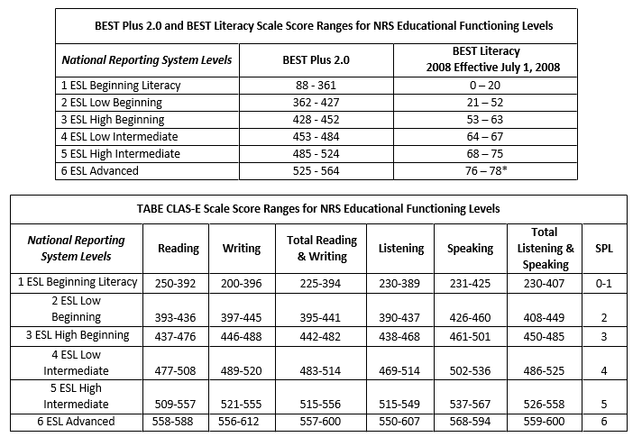
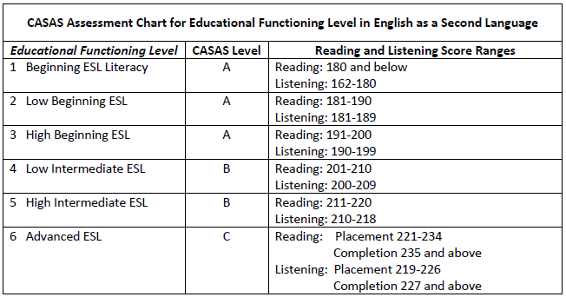

Equal opportunity employment/program. Auxiliary aids and services are available upon request to individuals with disabilities.

OKJobMatch Virtual IEP
The following instructions are for the completion of the Individual Employment Plan found in the WIOA Program Enrollment section of OKJobMatch. A summary or narrative of each IEP component must be entered in the virtual IEP, as described in OWDI #03-2019.
 | IEP Components | Instructions
1. | Comprehensive & Career Research. | - Identify all comprehensive assessment tools used, including any known assessments given by partner entities.  - List the date or dates assessments were completed.  - Summarize assessment results.  - Provide a brief overview of the participant’s employment history.  - Document any career research completed by/reviewed with the participant.  - Indicate whether participant has a clear understanding of job requirements based on research completed, including labor market information (LMI), when appropriate.  - Address the action taken when results of the career research are not in alignment with assessment results.
2. | Employment Goals & Achievement Objectives. | - Identify the employment goal(s) and address alignment with assessment results.  - Identify a timeline for achieving the major employment goal, including achievement objectives leading to the goal.  - If applicable, identify short term and long-term employment goals (e.g., a participant’s career pathway).
3. | Training Goals and Achievement Objectives. |  | - Document that training is necessary to achieve the identified employment goal and/or career pathway goals.  - Identify whether the participant is currently enrolled in training and needs assistance for completion.  - List the type of training, including occupational skills training (OST), on-the-job training (OJT), or other work-based training such as work experience, registered apprenticeship, or a transitional job. Note: The justification for work experience or a transitional job must be entered in section 5.  - Ensure training is for a demand occupation or required for a career pathway that leads to a demand occupation.  - Provide a detailed description of the participant’s training plan, including the training provider, the dates of training, and identification of achievement objectives expected or resulting from the training program attendance.  - Modifications to the training plan must be documented in the IEP as they occur, including:  - Date of modification  - Modification number  - Identification of what is being modified (i.e., record the need and necessary actions to resolve the need).  - Note: A modified training goal must remain aligned with the participant’s career pathway/employment goal and any change to the training plan will require an updated Client Involvement Statement.
4. | Client Strengths and Attributes. |  | - Summarize skills and experiences from prior employment, training, hobbies, volunteer work, and home/family responsibilities as they relate to the employment goal.  - Consider any personal characteristics, assets, and resources that can be related to the employment goal.
5. | Combination of Services to Overcome Needs/Barriers. |  | - Address the appropriate combination of services for the participant to achieve their employment goals. The following barriers must be addressed if identified, and necessary services to overcome all identified barriers must be entered.  - Basic skills deficient;  - School Drop Out;  - Lacks skills, training, or a credential;  - Criminal record;  - English as a Second Language (ESL);  - Lack of transportation;  - Substance Abuse;  - No Driver’s License;  - Lack of Child Care;  - Difficulty finding employment;  - Poor work history, i.e., chronic unemployment or inconsistent work history;  - Homeless; and  - Other identified barriers, as observed, stated by the participant, or listed in the client’s Demographics section of OKJobMatch.  - Include a statement regarding the need for a Transitional Job or Work Experience.  - List any short-term prevocational skills to be provided, such as communications skills, development of learning skills, personal maintenance skills, professional conduct, etc.  - List identified solutions to the needs/barriers listed, including  - Who will provide the service?  - Date service is expected to be started and completed  - Document any referrals made to partner agencies and community partners.
6. | Assistive Technology Needs for Achieving Goals. |  | - Address any requested reasonable accommodations without the mention of a disability or details of a disability.  - If applicable, enter a general statement regarding requested assistive technology needs, if any, for seamless customer service delivery.  - Enter N/A if this section does not apply.
7. | Client Responsibilities and Agency Responsibilities. |  | Include responsibilities required by the NEWDB policy and/or the NEWDB procedures that are not addressed in the Client Involvement Statement.  Client Responsibility examples:  - Frequency for contacting the designated WIOA case manager;  - Frequency for face-to-face meetings with the WIOA representative;  - Requirement to actively seek and accept training related employment upon completion of services, which may include feedback regarding employment search, e.g., application and resume submission, interviews scheduled or completed, and follow-up with employers;  - Attend training regularly and provide verification of satisfactory training progress, as requested;  - Provision of specific information regarding attained employment before leaving the program, including the name of employer, job title, start date, rate of pay, benefits received or eligible to receive, etc.;  - Respond to all surveys and other requests for information after leaving the program, including the follow-up interview;  - Timely notification of changes in training status, including non-attendance and adding or dropping classes;  - Reporting eligibility for Pell or other grants or financial assistance;  - Reporting address or phone number changes; and  - Other responsibilities, as determined by NEWDB policy and procedures.  Responsibilities of WIOA staff may include:  - Oversight/regular monitoring of training activities,  - Submission of appropriate paperwork in a timely manner,  - Providing regular support and assistance as necessary for program success,  - Providing career and job search guidance,  - Ensuring appropriate referrals to workshops and partner entities to enhance the client’s success in the job market, and  - Other responsibilities, as determined by NEWDB policy and procedures.
8. | Economic Need Statement and Planning. |  | - Summarize the financial needs articulated by the client through the interview, assessment, and enrollment process.  - For the Adult program, enter the Priority of Service Category.  - Document Pell eligibility/ineligibility, as well as exploration and documentation of other financial aid options such as Tribal funds, scholarships, TAA, education funding for Veterans, etc.  - Note if the participant is in default on student loans and document any steps taken to help the individual get out of default, e.g., the provision of financial literacy information.  - Other information as per NEWDB policy and procedures.
9. | Supportive Service Needs. |  | This section pertains specifically to supportive services provided with Title I funds, not partner provided services, which are addressed in section 5.  - Enter the supportive services provided and a brief statement as to the necessity of the service.  - Document the date of provision, amount, etc.;  - Provide an explanation of why any requested supportive services were not provided.
10. | Follow-up Services Planned. |  | For individuals in the Adult and DLW programs:  - Enter details about planned follow-up services after employment attainment.  - Document the services as they occur.
11. | Performance Goals & Accountability Indicators. |  | - List measurable skills gains that are expected according to the training plan.  - List the credentials that are expected outcomes of the training goals/training plan.  - List planned credential attainment dates.
12. | Client Progress Review. |  | - Include a brief summary of how the individual is progressing in the current phase of their employment plan, based on feedback from the participant, an instructor or supervisor, or documents provided such as grades, certificates of completion, etc.  - Indicate the progression made or difficulties encountered during the review period. For example: Training was successfully completed four months ago but Joe has not yet attained employment. A mock interview was set up with ABC, Inc. and it was determined that he does not interview well and also needs resume assistance. A new entry has been entered in section 5, Combination of Services to Overcome Needs/Barriers.  - Any modifications to the IEP resulting from a progress review must be documented in the appropriate section. For example, employment goal, training goals, supportive services, etc.
13. | Additional Notes. |  | Enter any additional information necessary to the IEP and success of the client, such as why there is a gap in service. For example: Joe’s mother passed away and he will travel to New York to attend the services and settle her estate. He has made arrangements with the training provider to resume training in three weeks when he returns to Oklahoma.
14. | Client Involvement Statement. |  | - Virtual attestation to the Client Involvement statement is made in OKJobMatch.  - For modifications to the original IEP not conducted in person with the participant, the case manager must schedule an appointment with the participant as soon as possible to review the IEP and obtain the virtual signature to the Client Involvement Statement.  - For case management only updates, check the box indicating a client agreement is not required.

Information found in the IEP, does not have to be duplicated in Program Notes, unless required by current Data Validation policy.

